**Alien Breed Portfolio**

**[The Main Character Modelling, Simple Texturing and Animation]**

Create a box

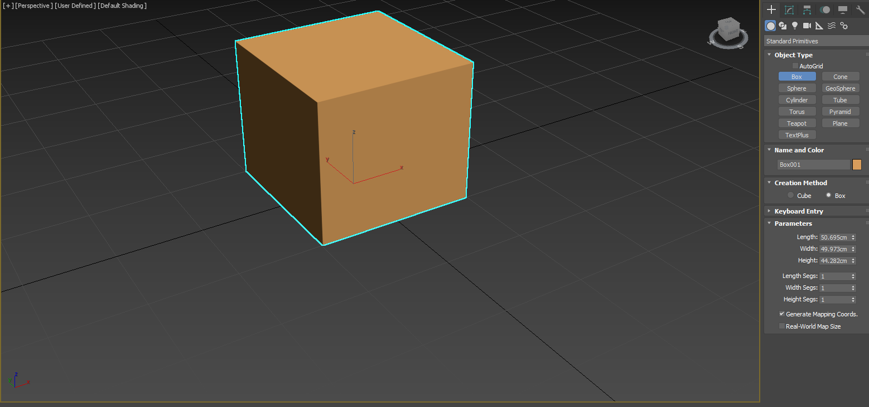

Move the box

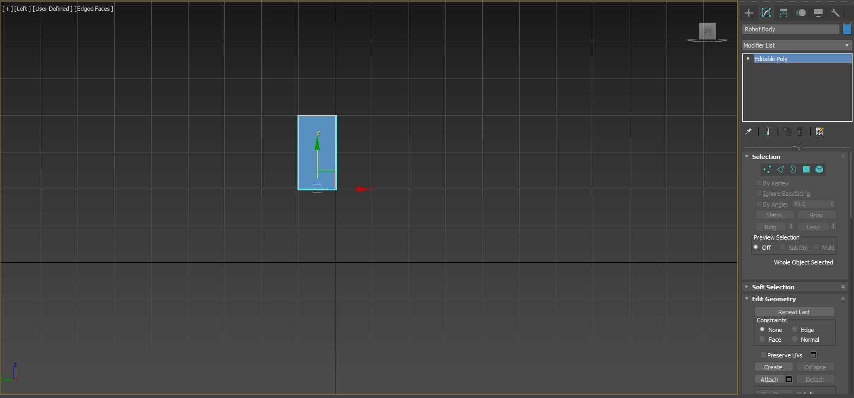

Rescale the box

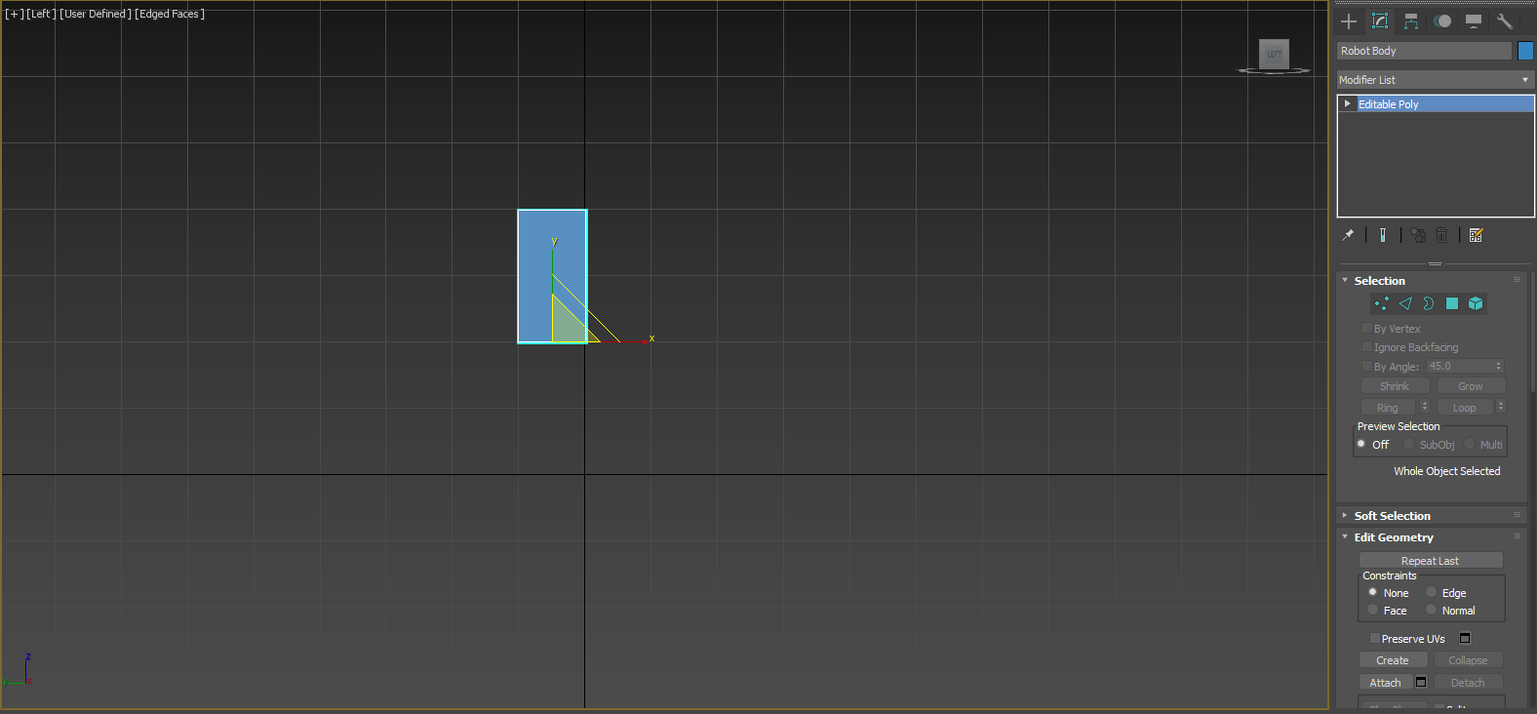

Inset tool

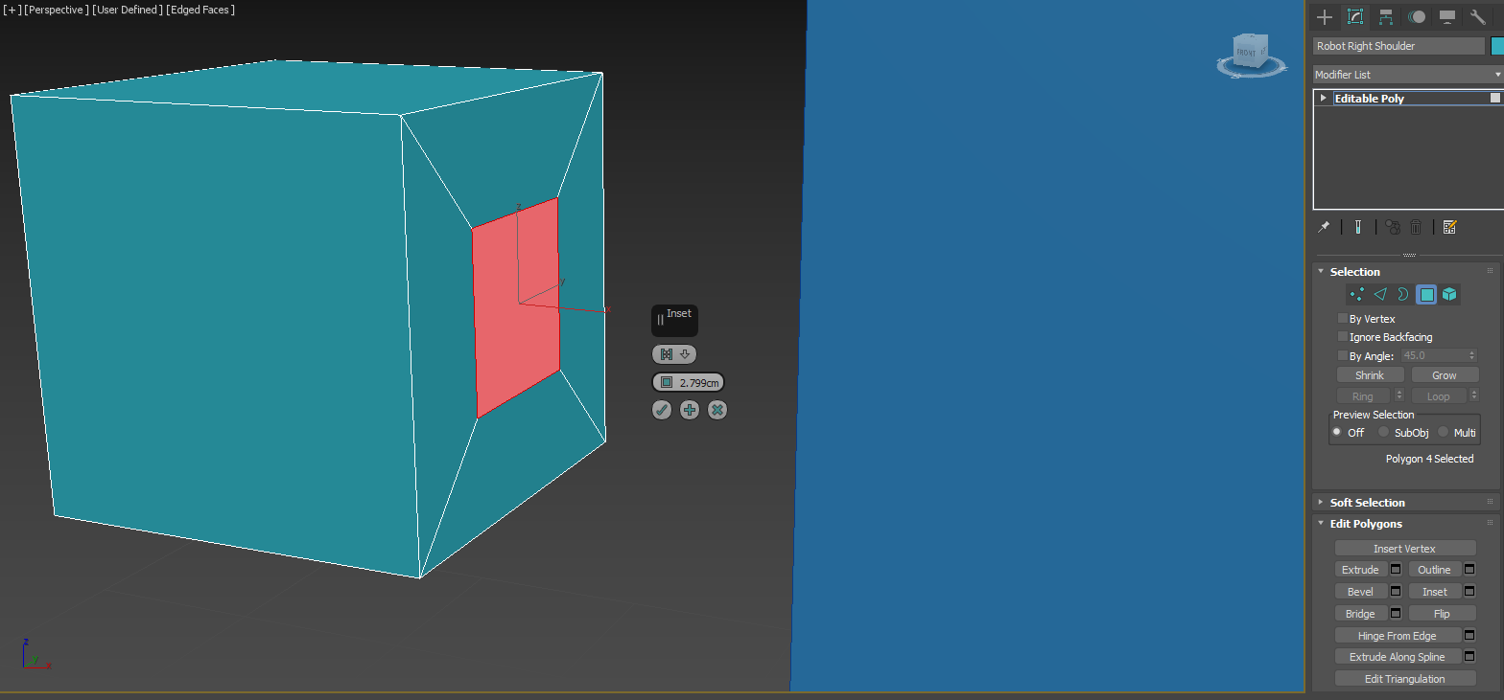

Bevel tool

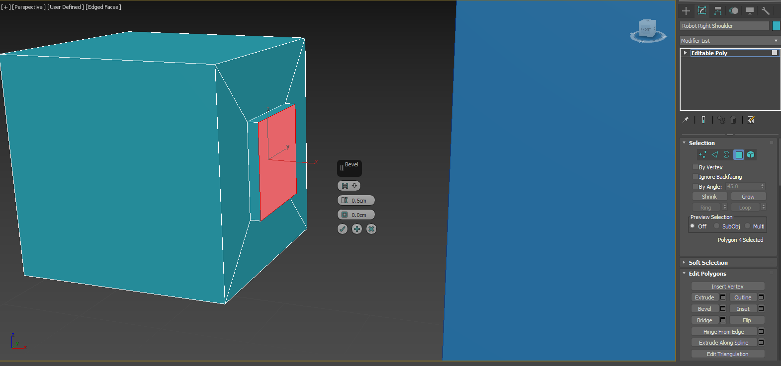

Add another layer

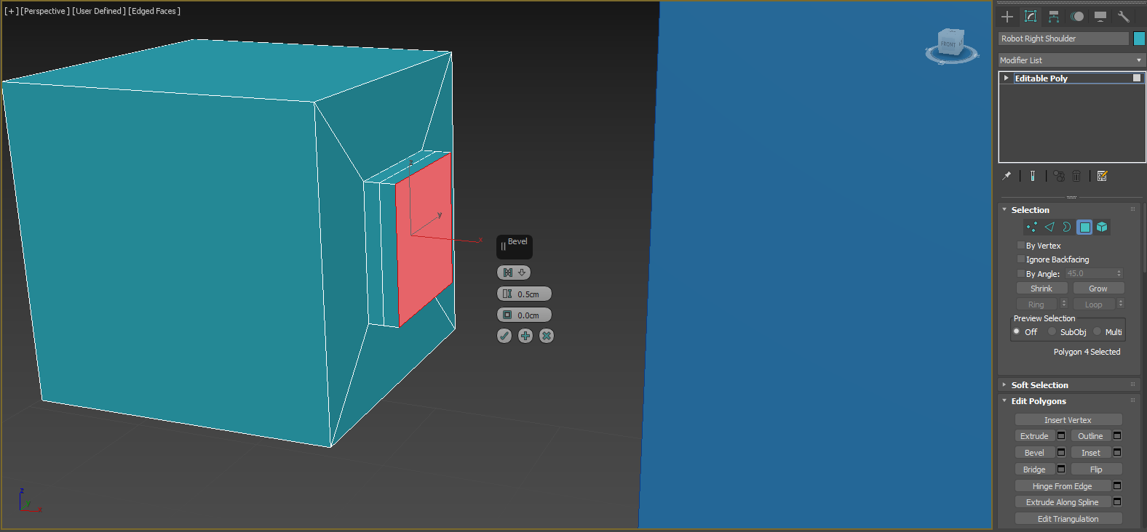

Extrude tool

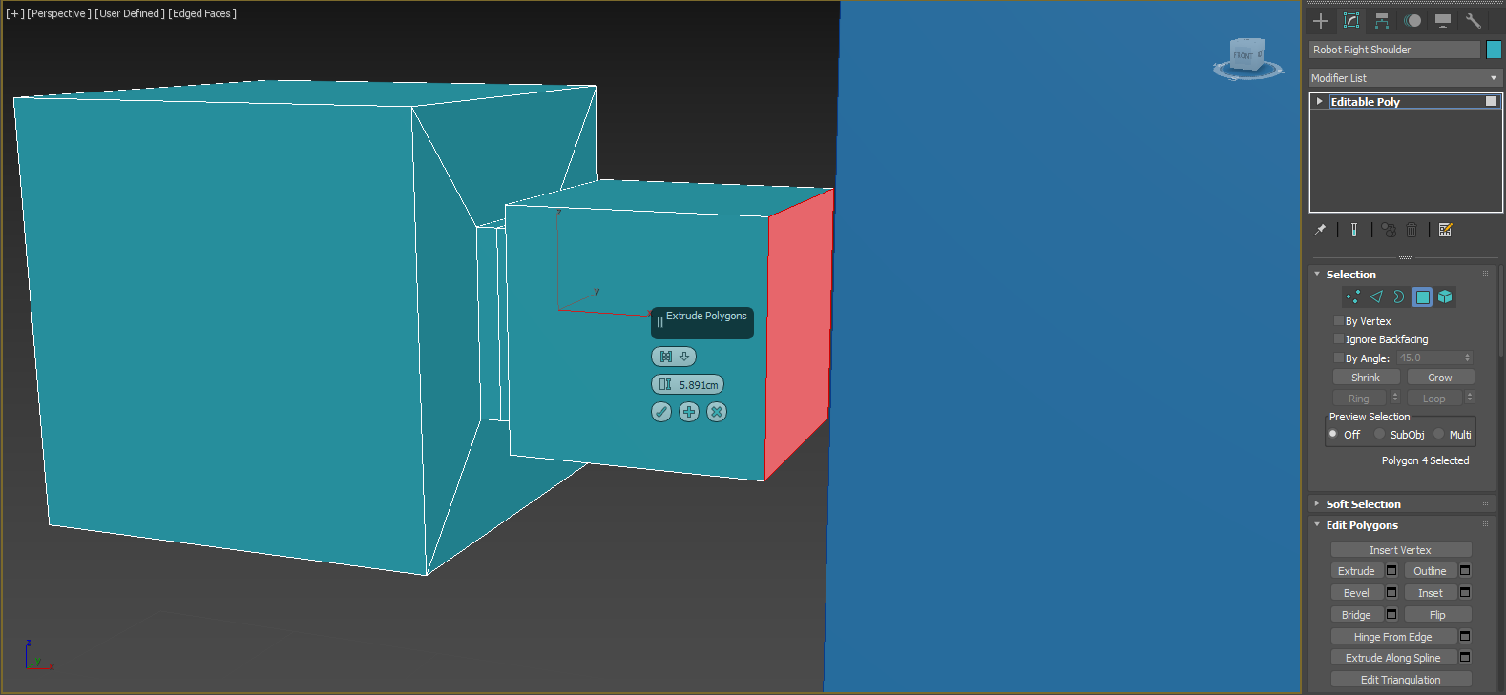

Swift Loop tool

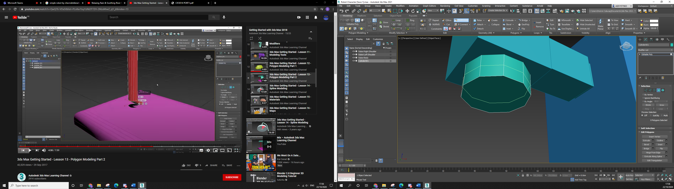

Extrude Tool

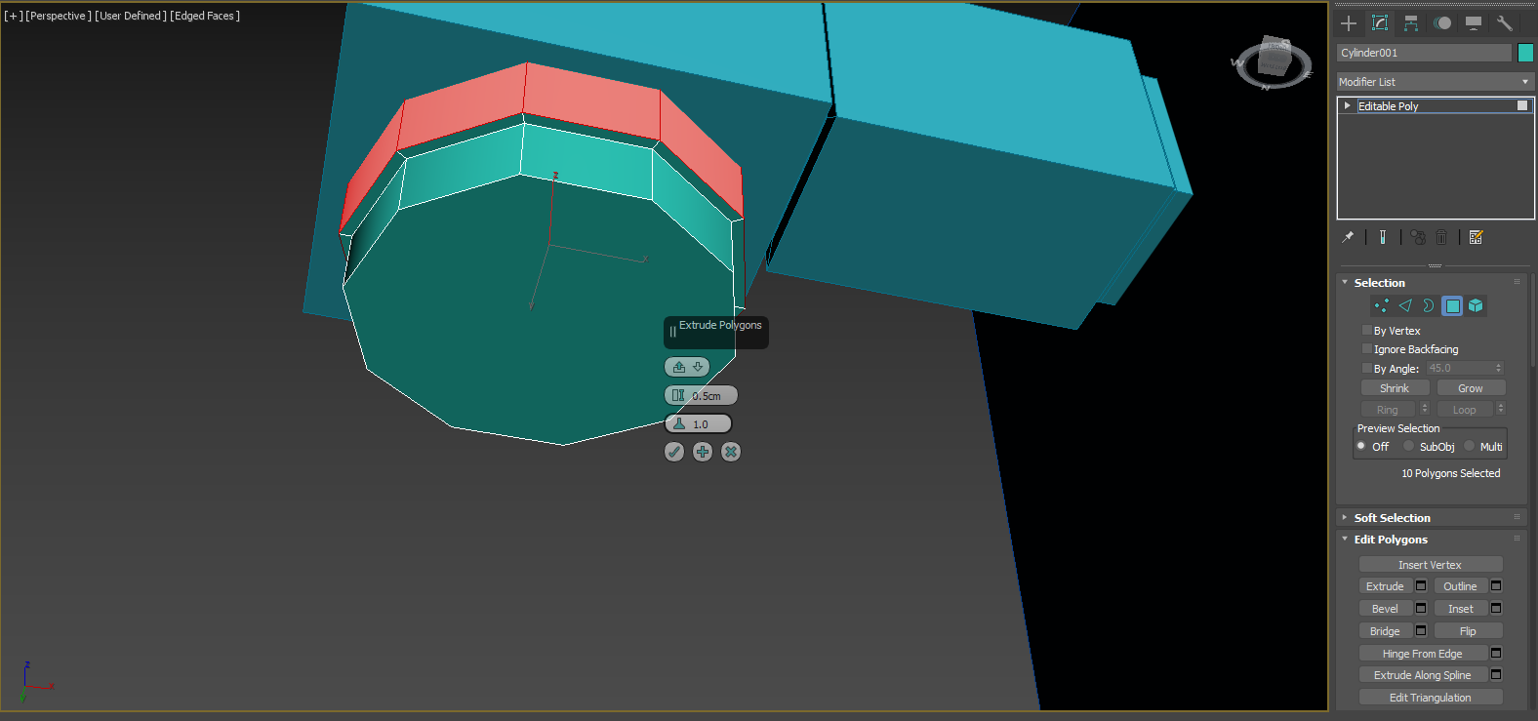

Polygon face rescaling

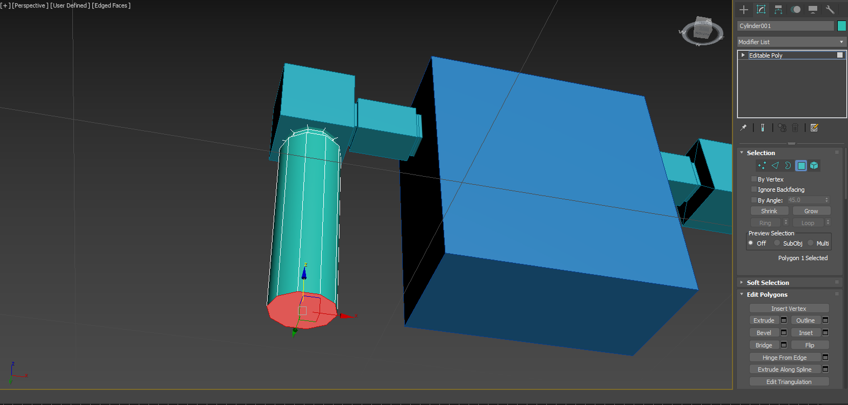

Clone tool

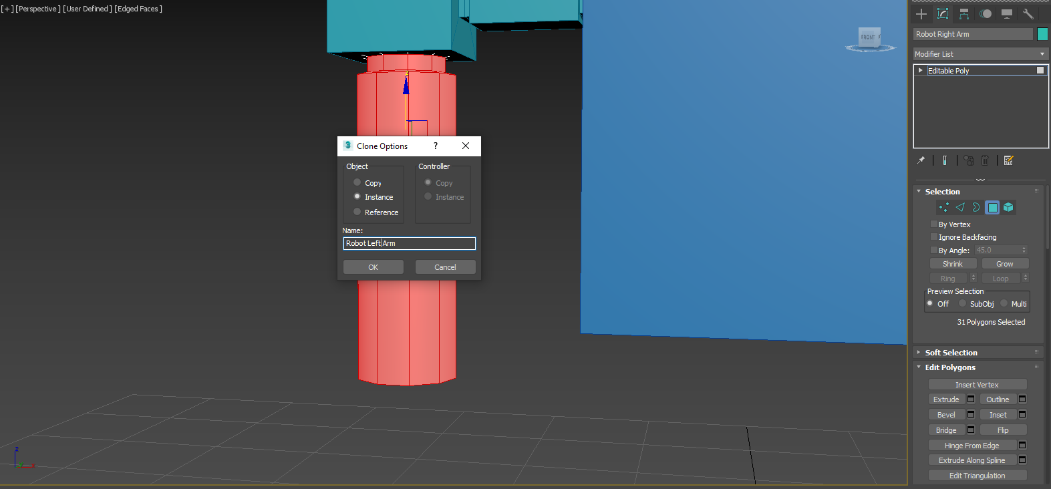

Boolean - Subtract

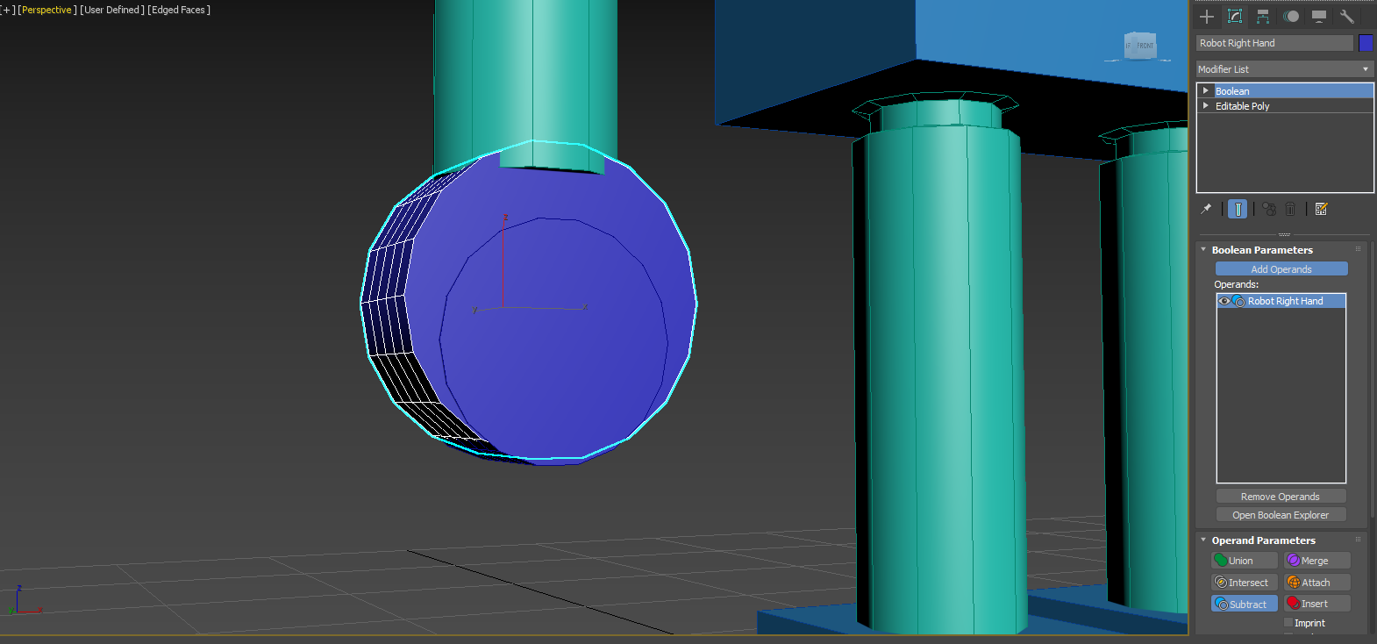

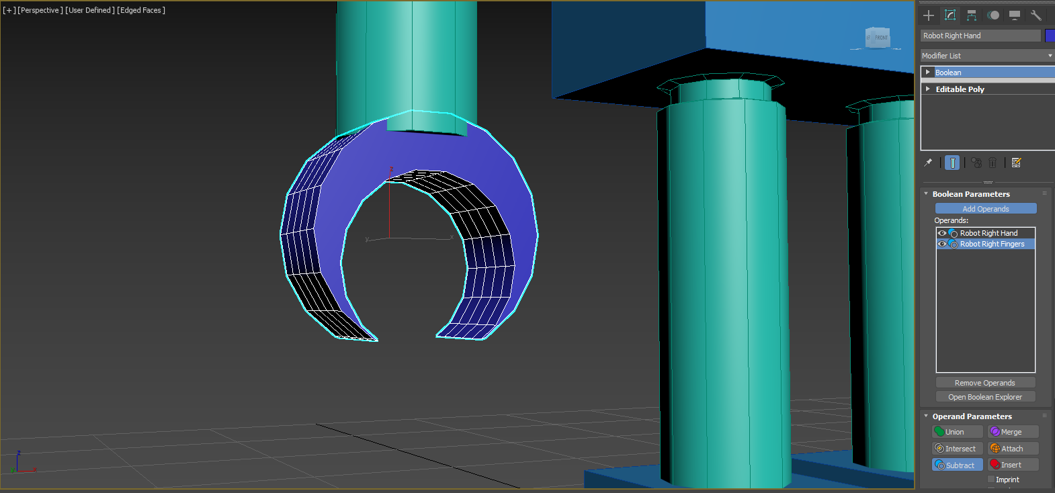

Boolean - Union

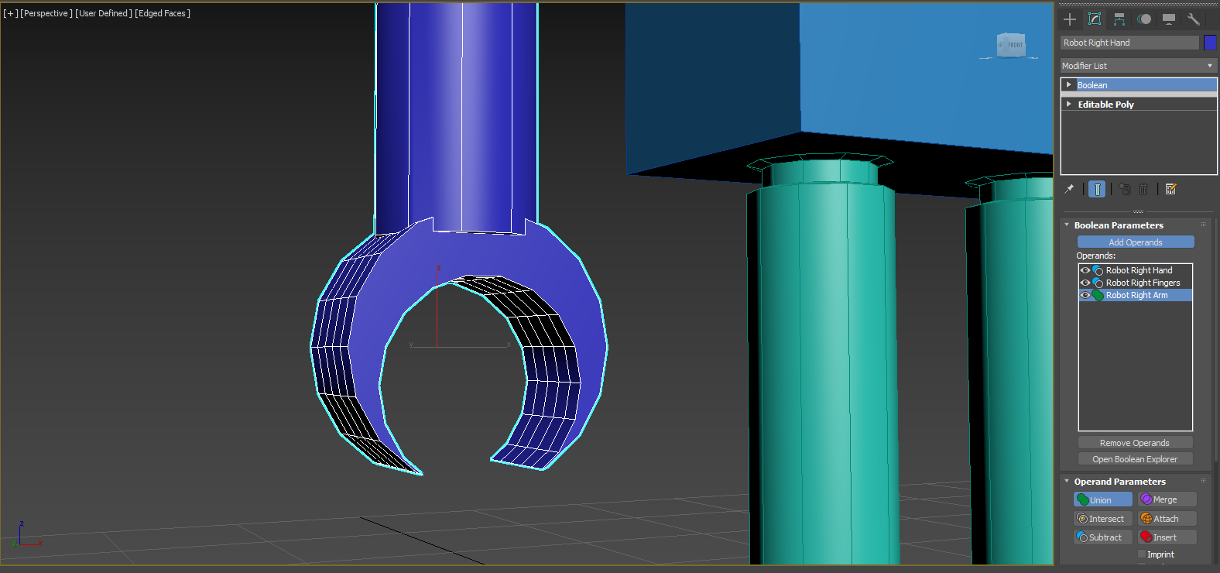

Convert to editable poly (Collapse)

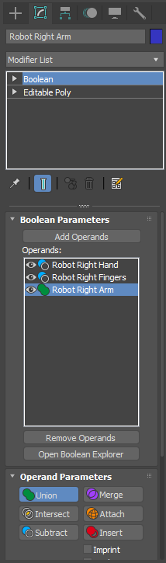

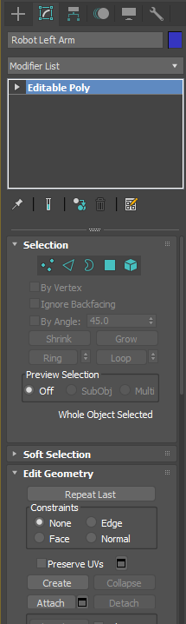

Clone tool

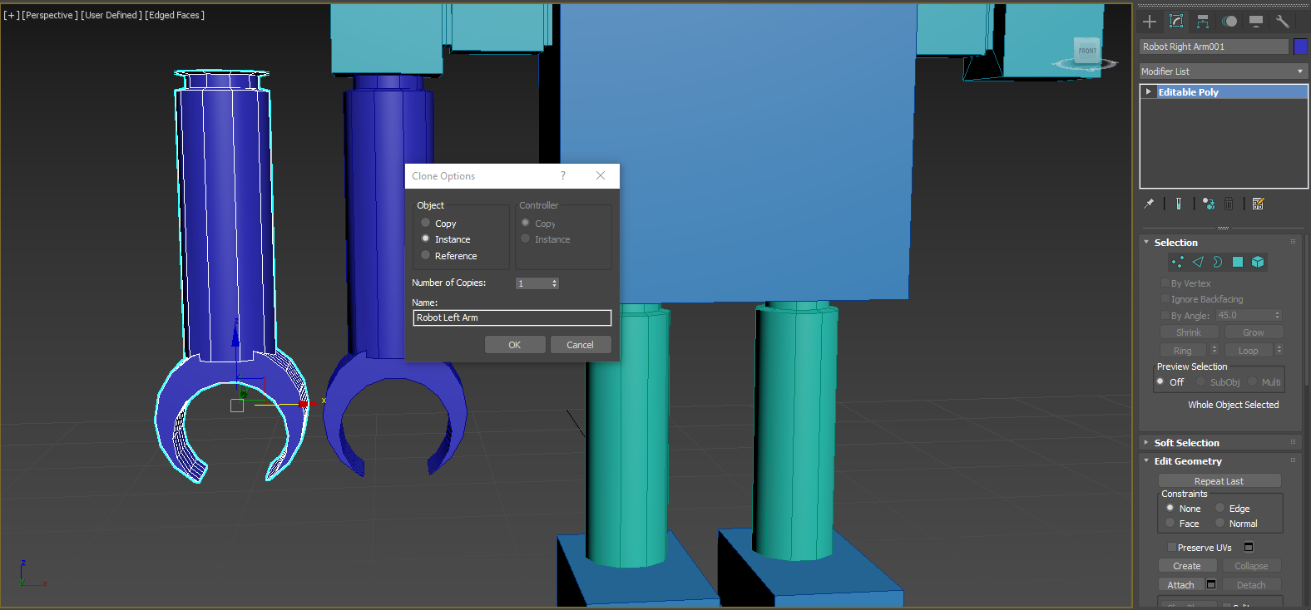

Boolean - Union

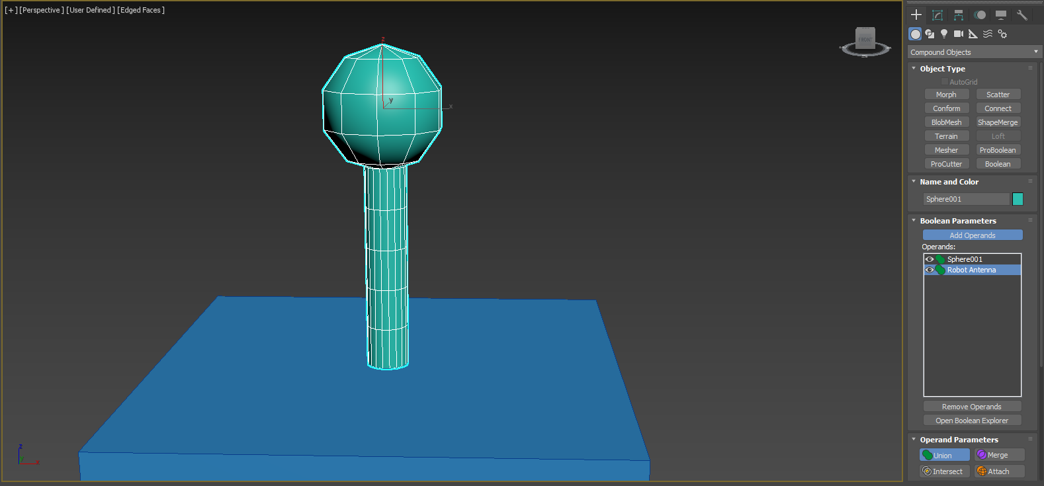

Boolean - Insert

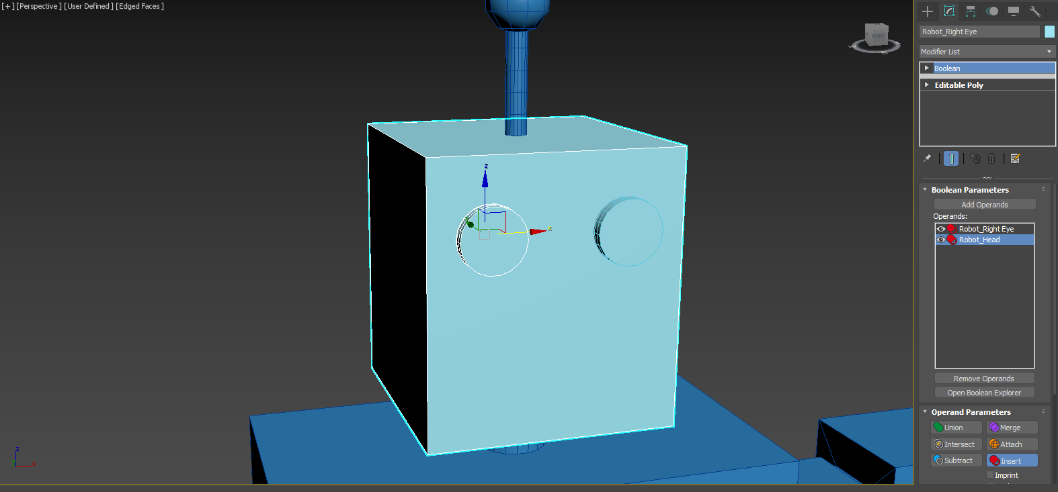

Boolean - Insert

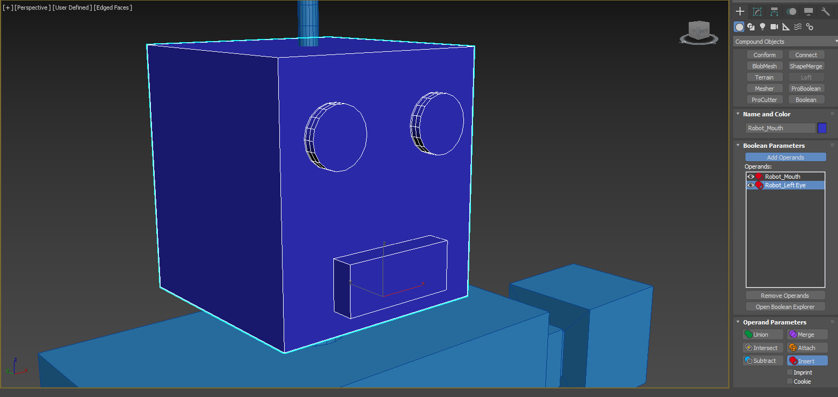

Chamfer on the edge

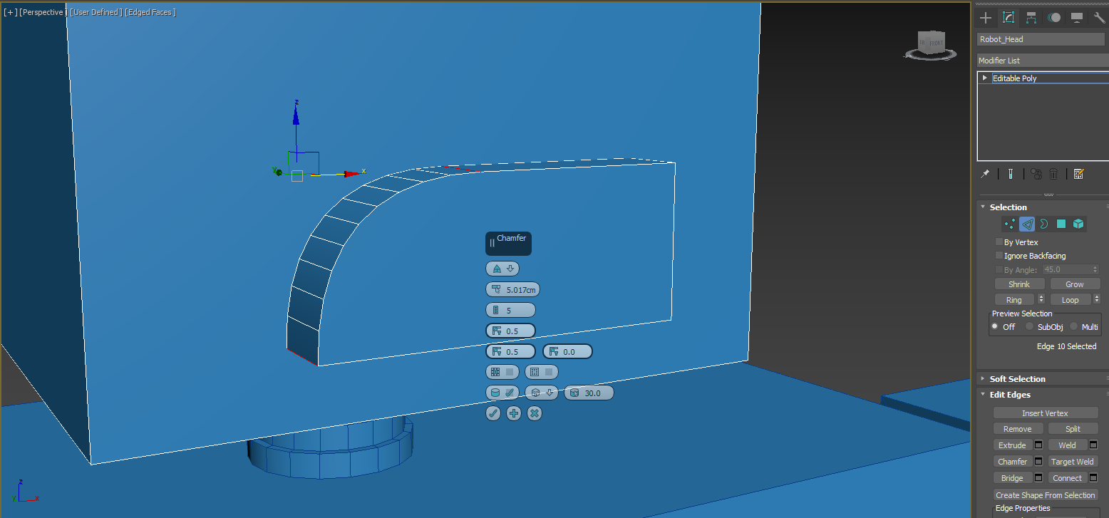

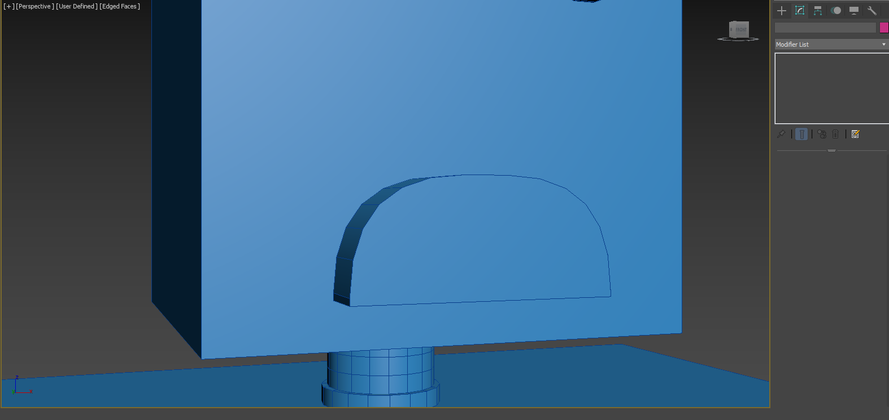

Organising different robot parts into hierarchies

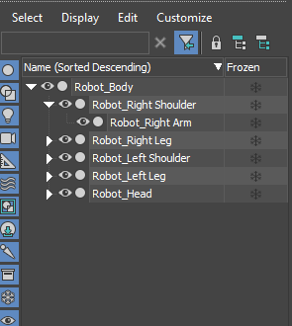

Slate material editor

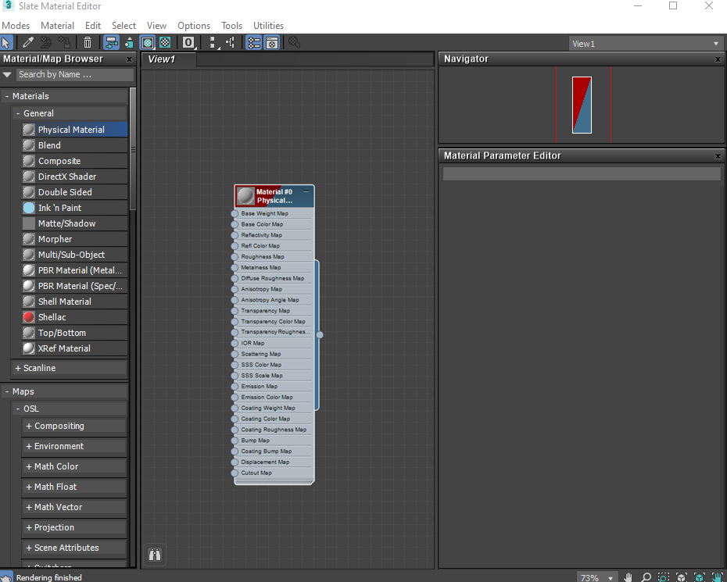

Assign the physical matte aluminum material to the robot body

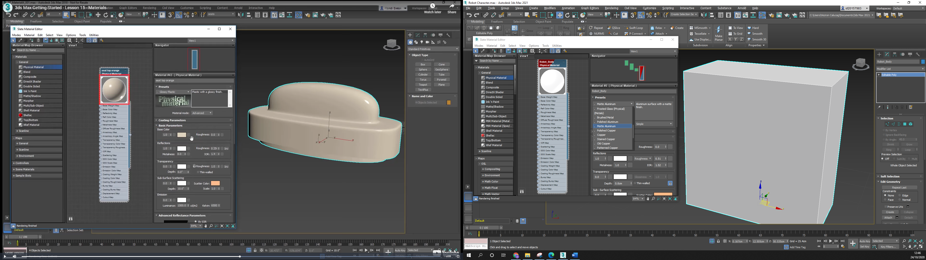

Apply light reflection

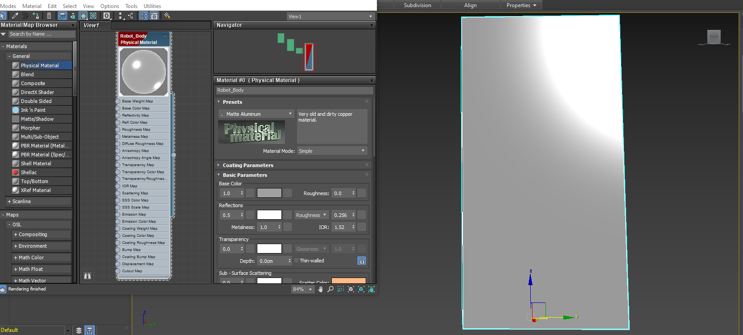

Apply to all robot body parts with polished aluminum

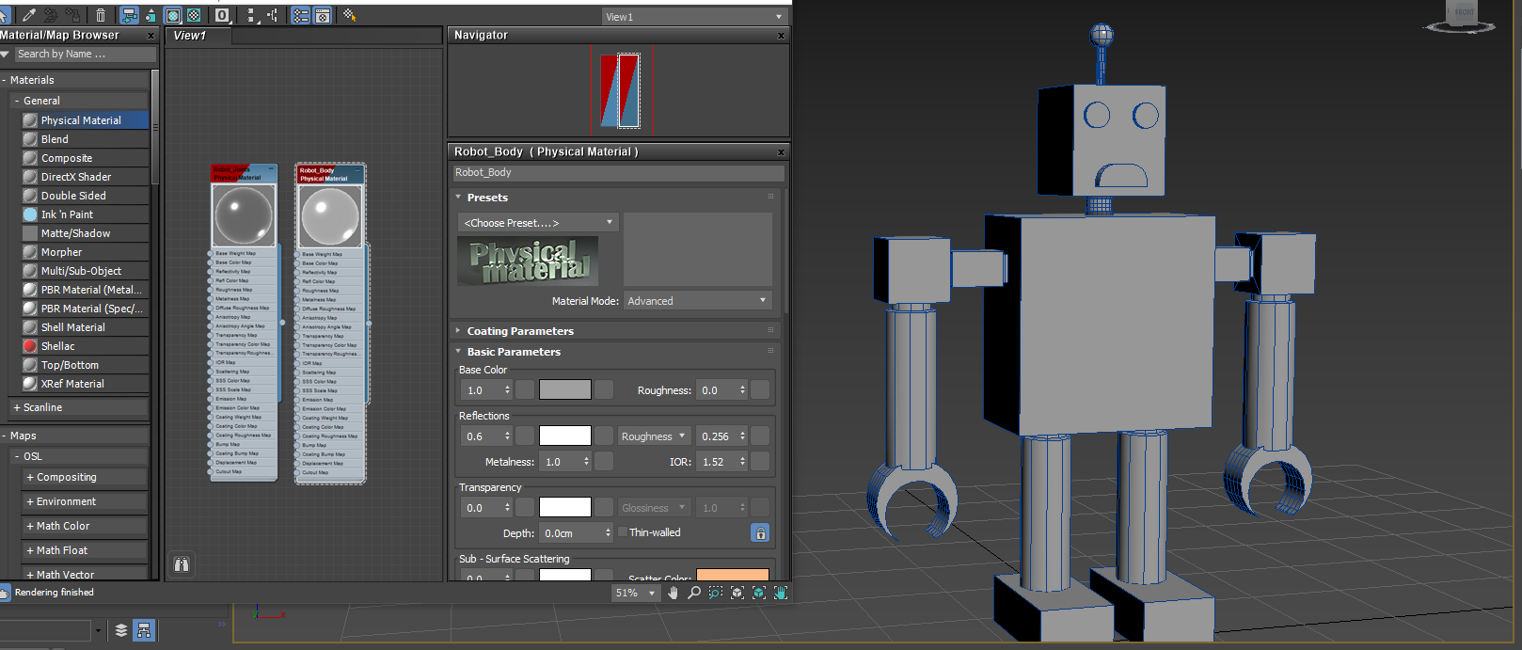

Apply the same physical matte aluminum material on different joints of the body with darker reflection

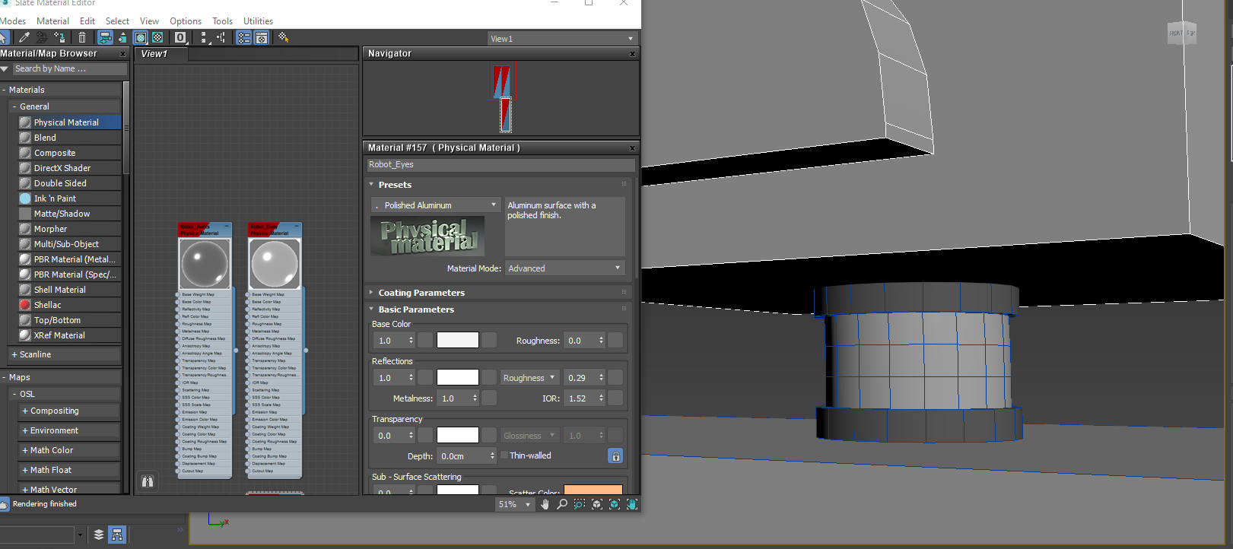

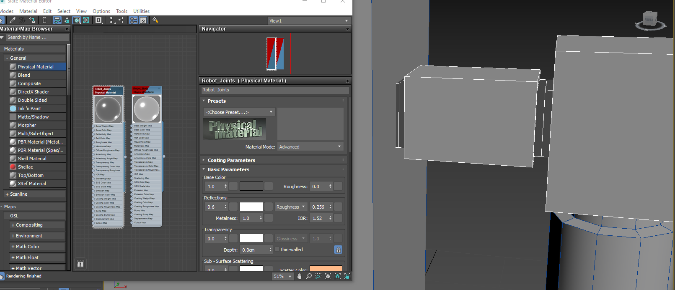

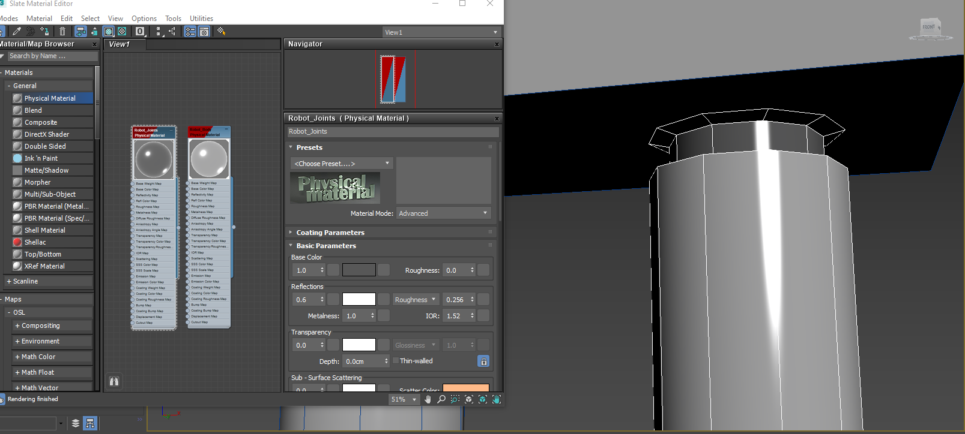

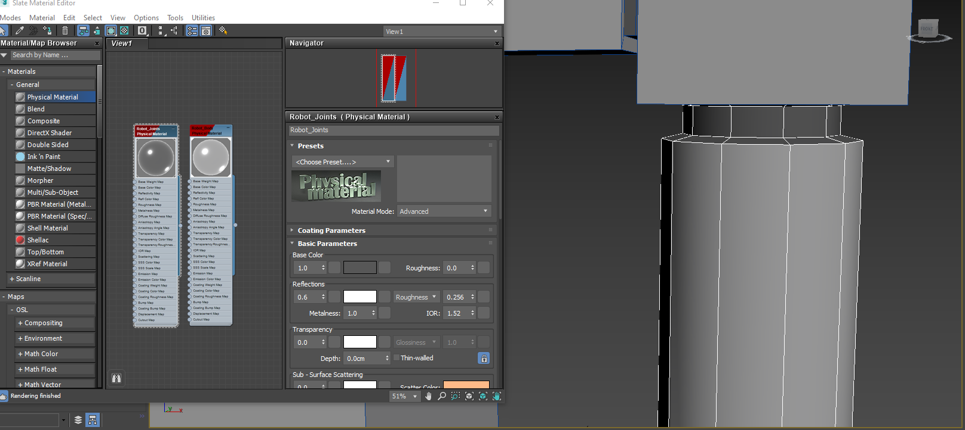

Apply physical polished aluminum material on the eyes and mouth with blue light reflection

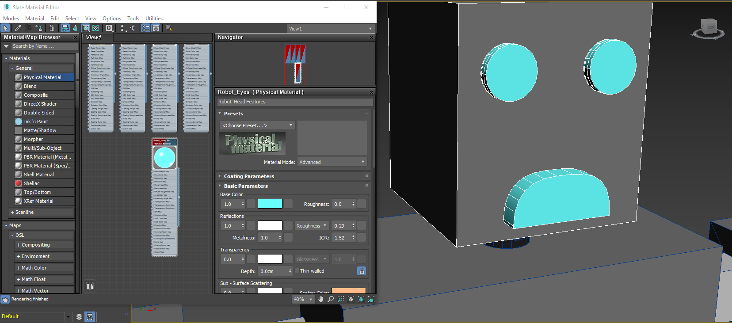

Apply physical matte aluminum material on robot limbs

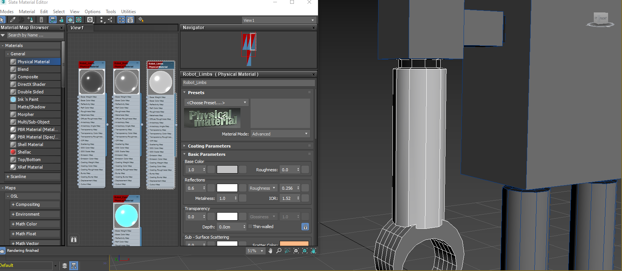

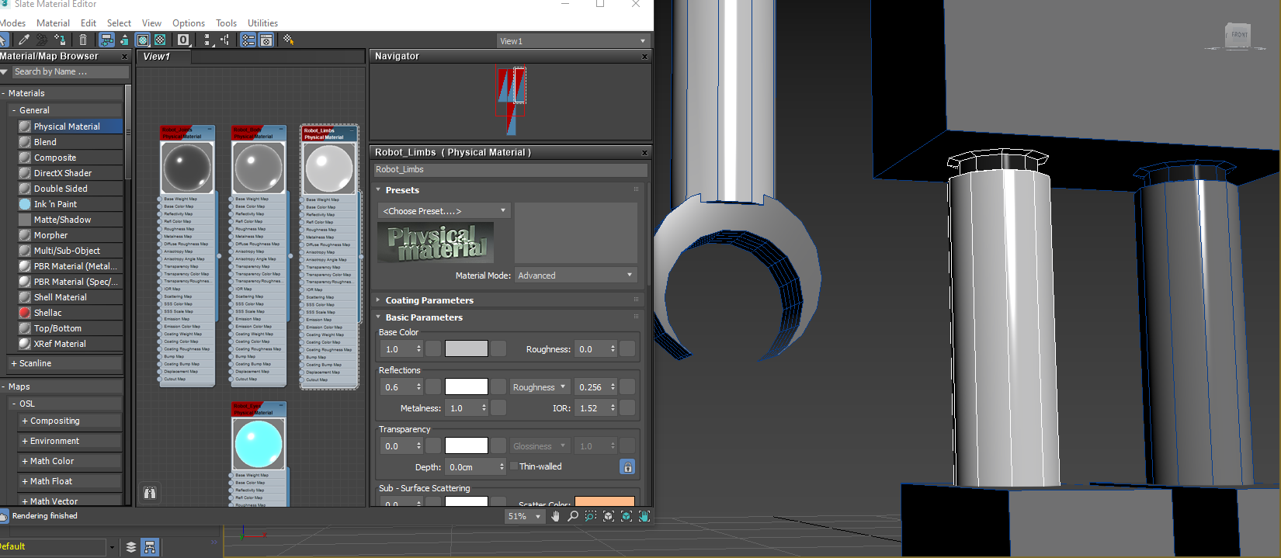

Apply glossy plastic material to the hands

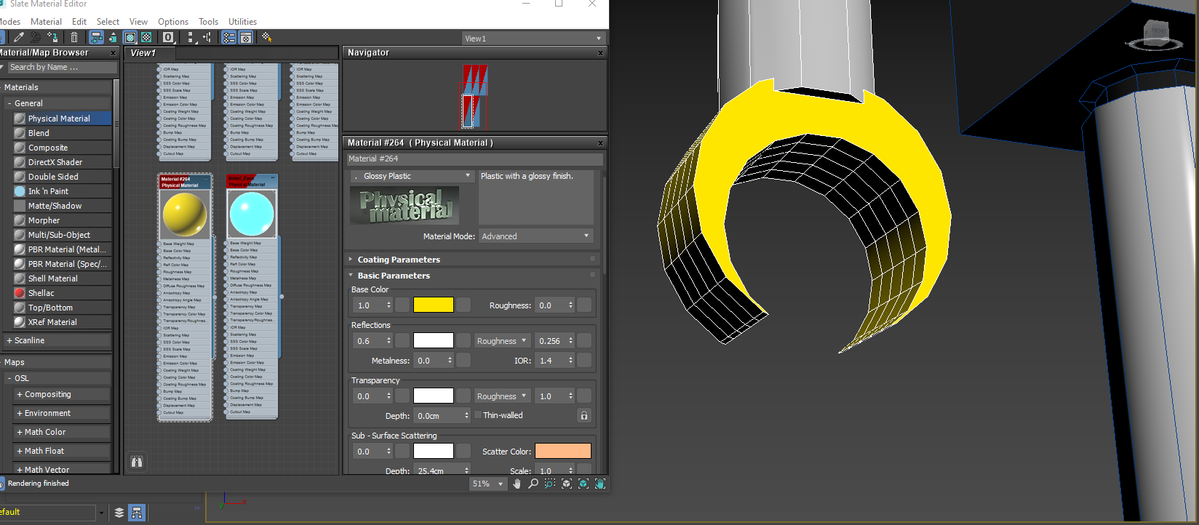

Place the pivot in the correct places

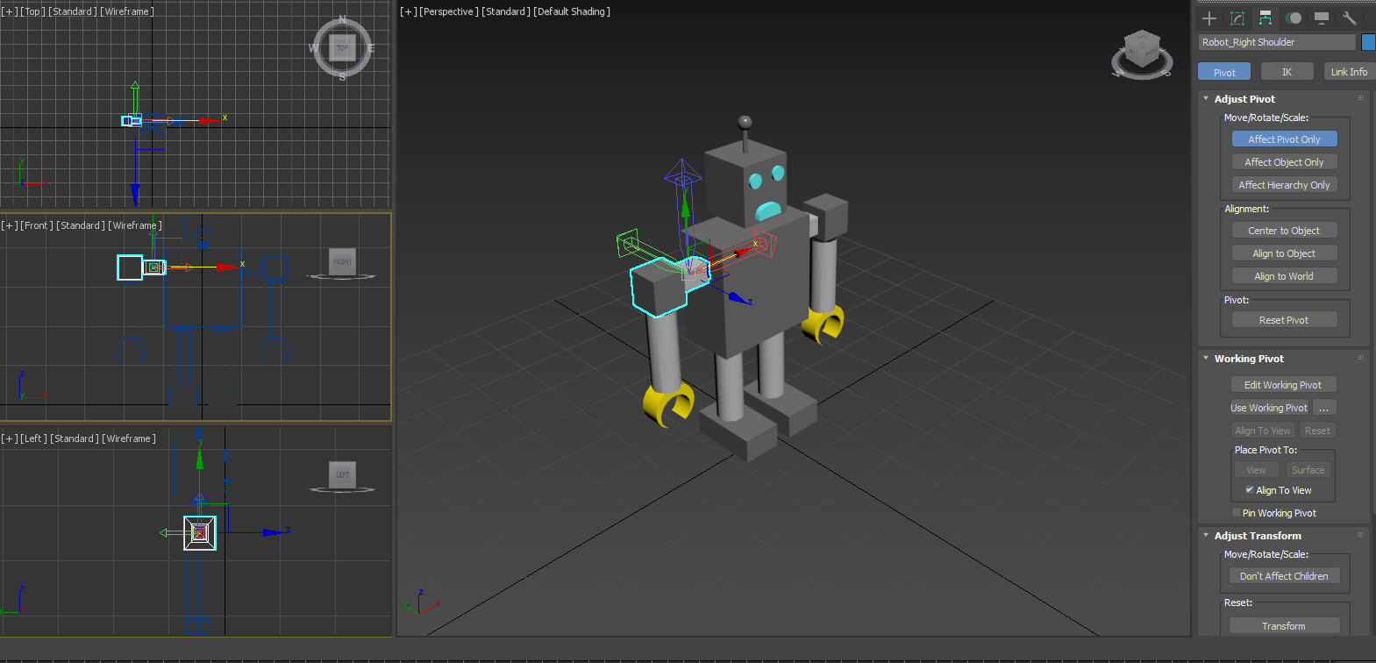

Link the arm and shoulder to the joint like linking a child to a parent

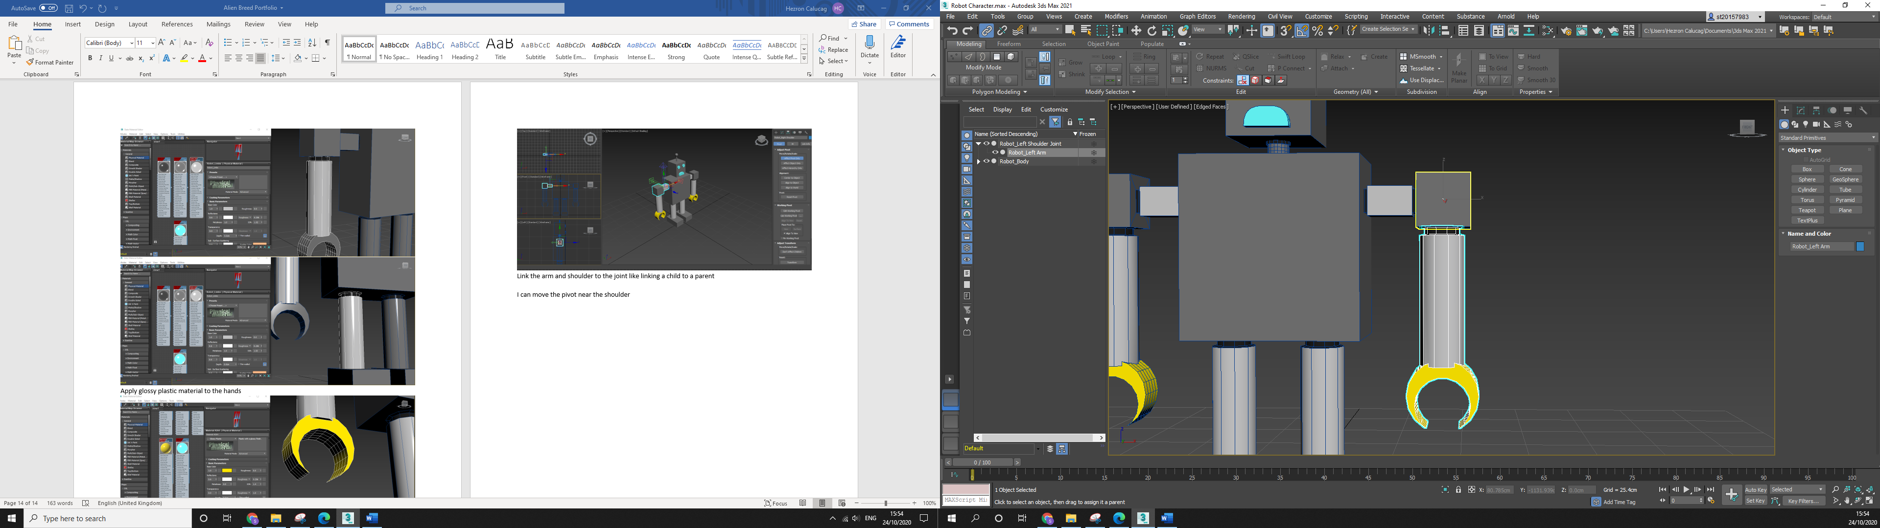

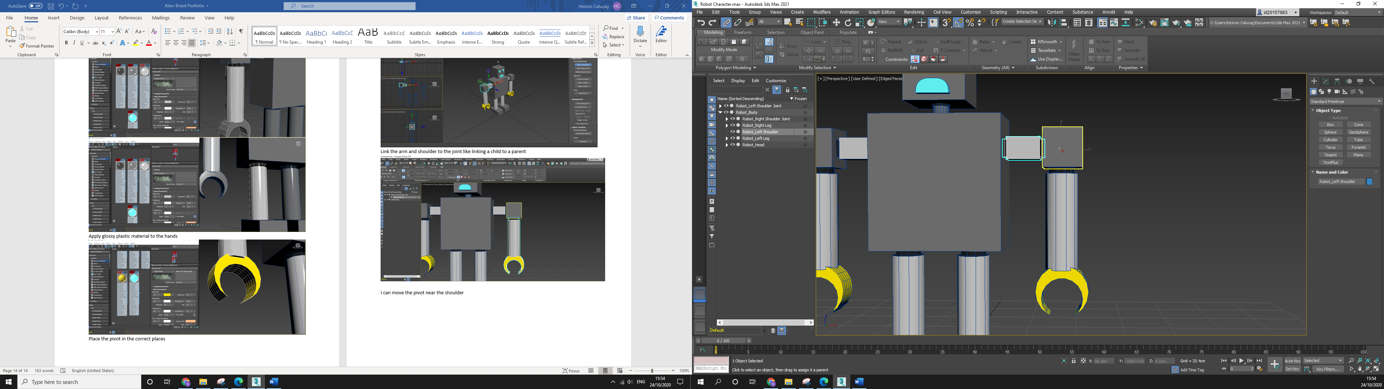

This creates another branch of hierarchies for arm animations

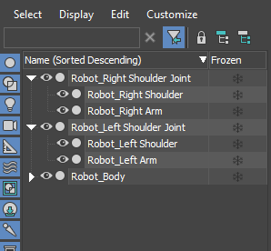

I can move the pivot in the shoulder joint to move the entire forearm

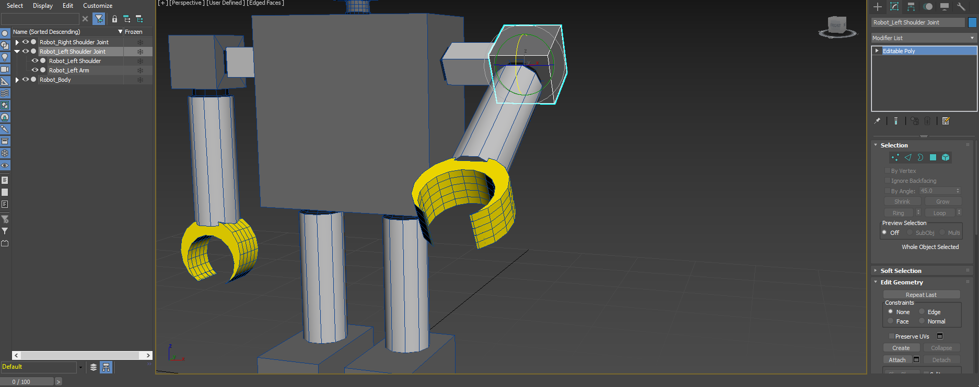

Creating arm animation by pressing ‘n’

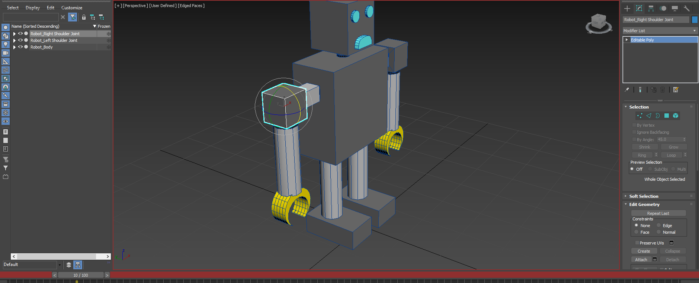

Making a keyframe with each arm position. Making moving arm animation for walking with a series of keyframes

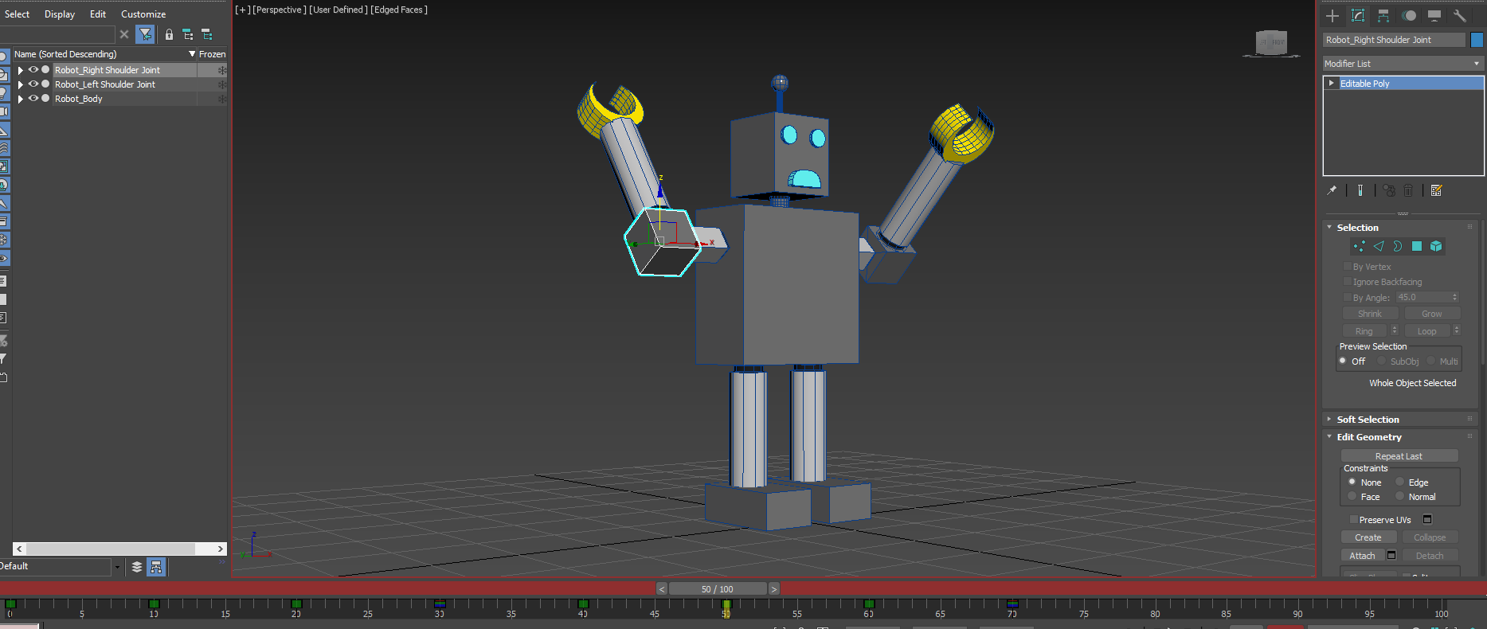

**[3D Level 1 & 2 Modelling and UVW Texturing]**

Create a plane object from top-view

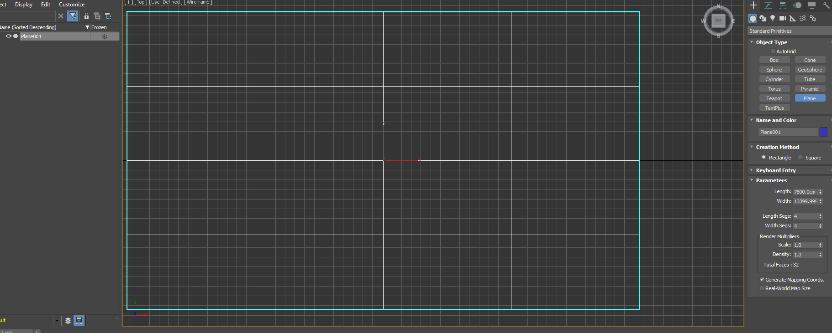

Insert my alienbreed map plan on diffuse map into 3DS max

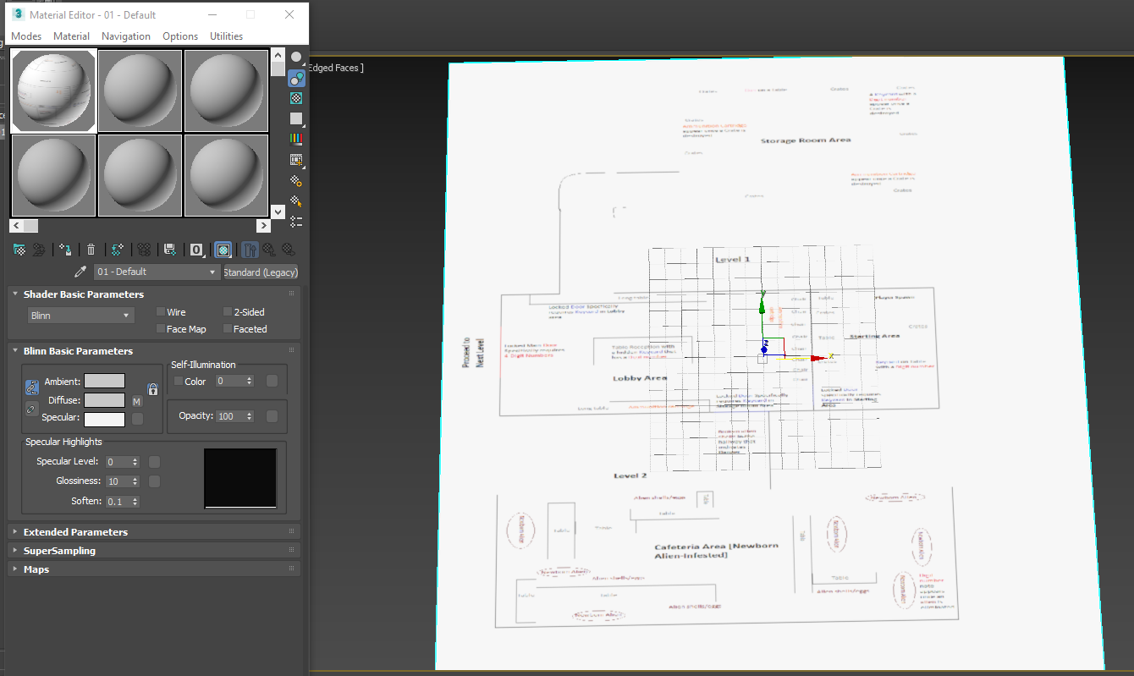

UVW Map modifier tool via Gizmo to adjust the image without moving the plane object

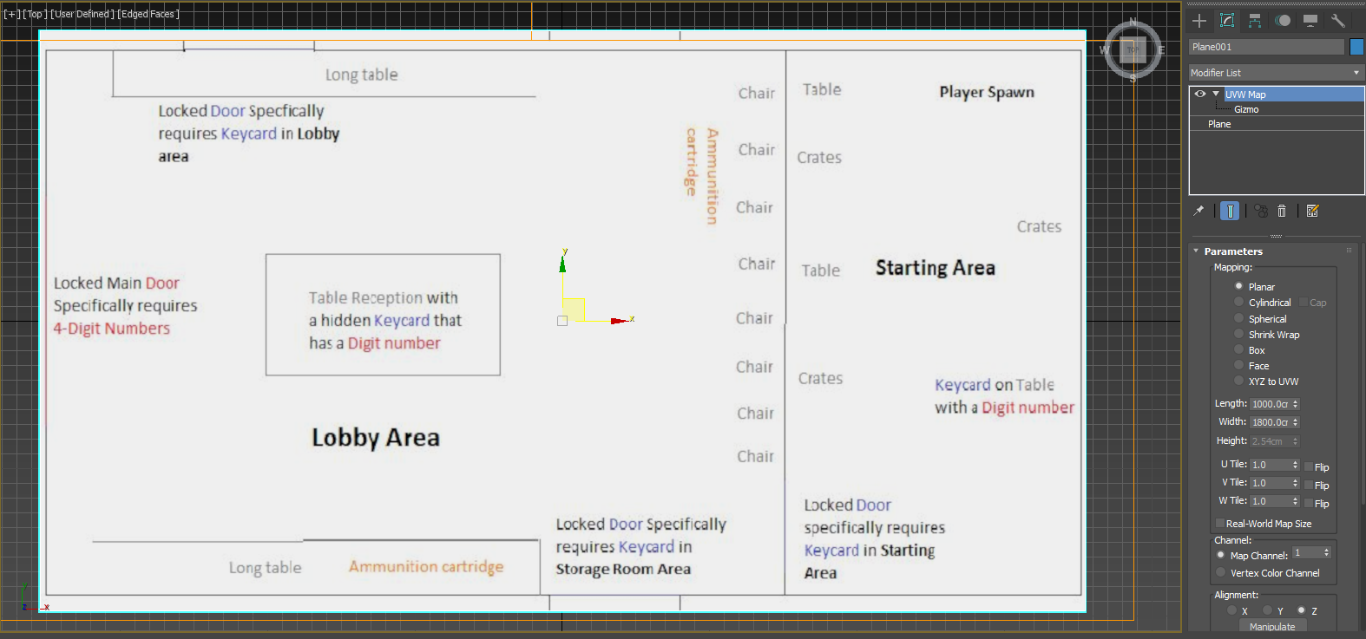

Make sure the plane object is editable to poly

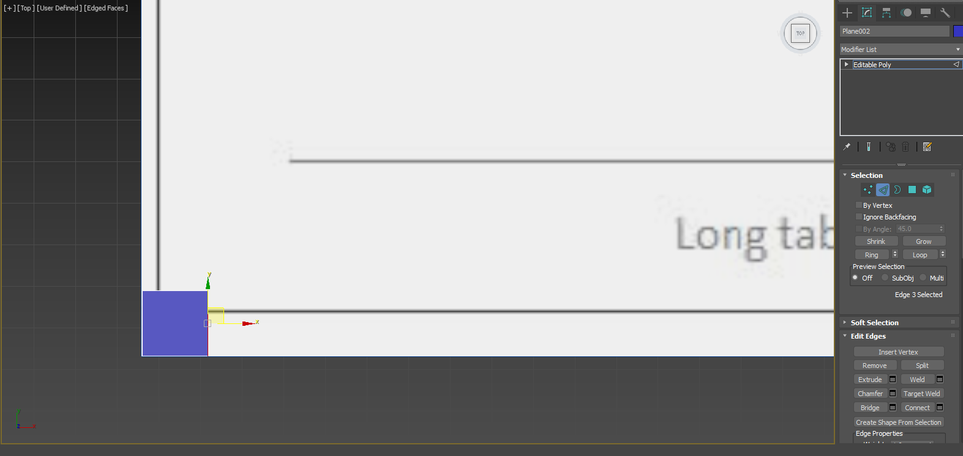

Using the edge tool to extend the plane object as it traces all the walls excluding door spaces

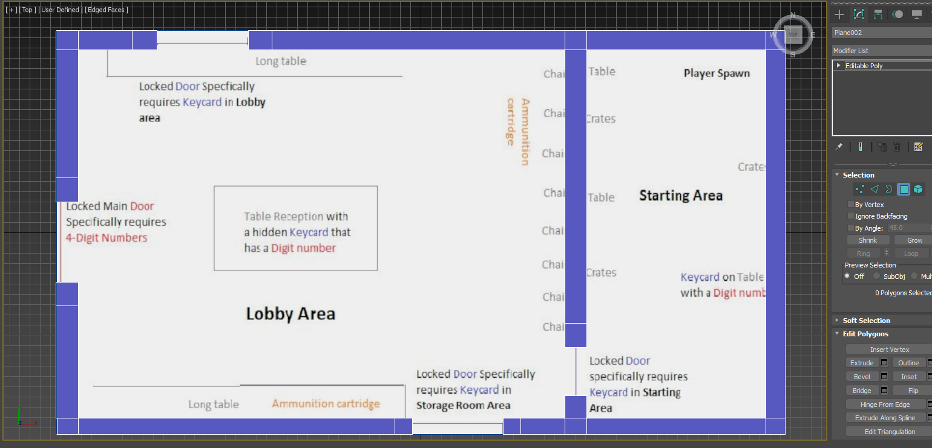

Extrude tool

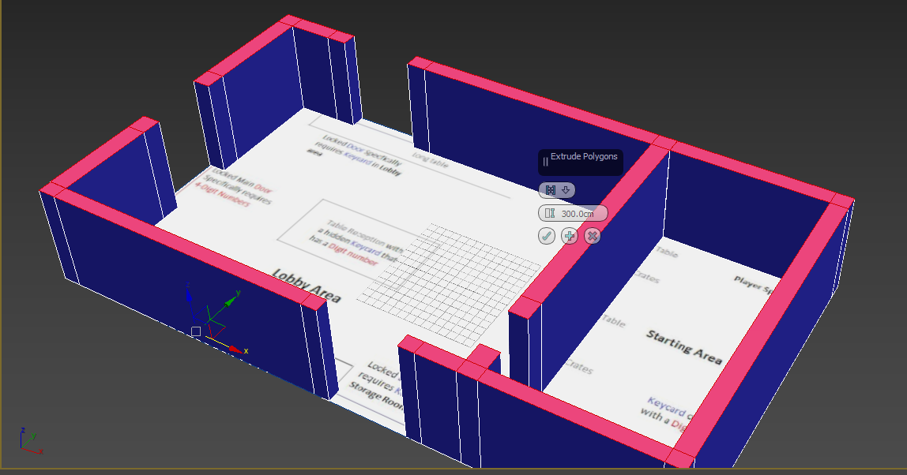

Insert the texture to bitmap from material editor

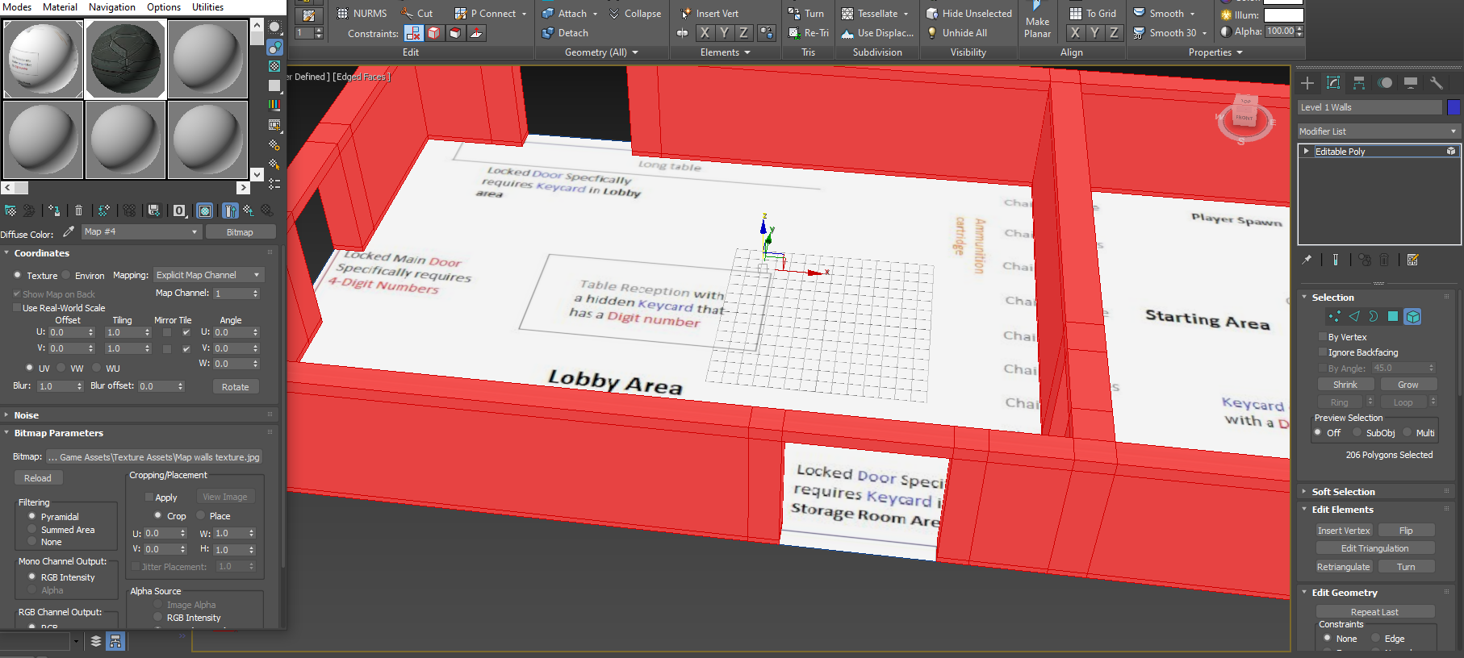

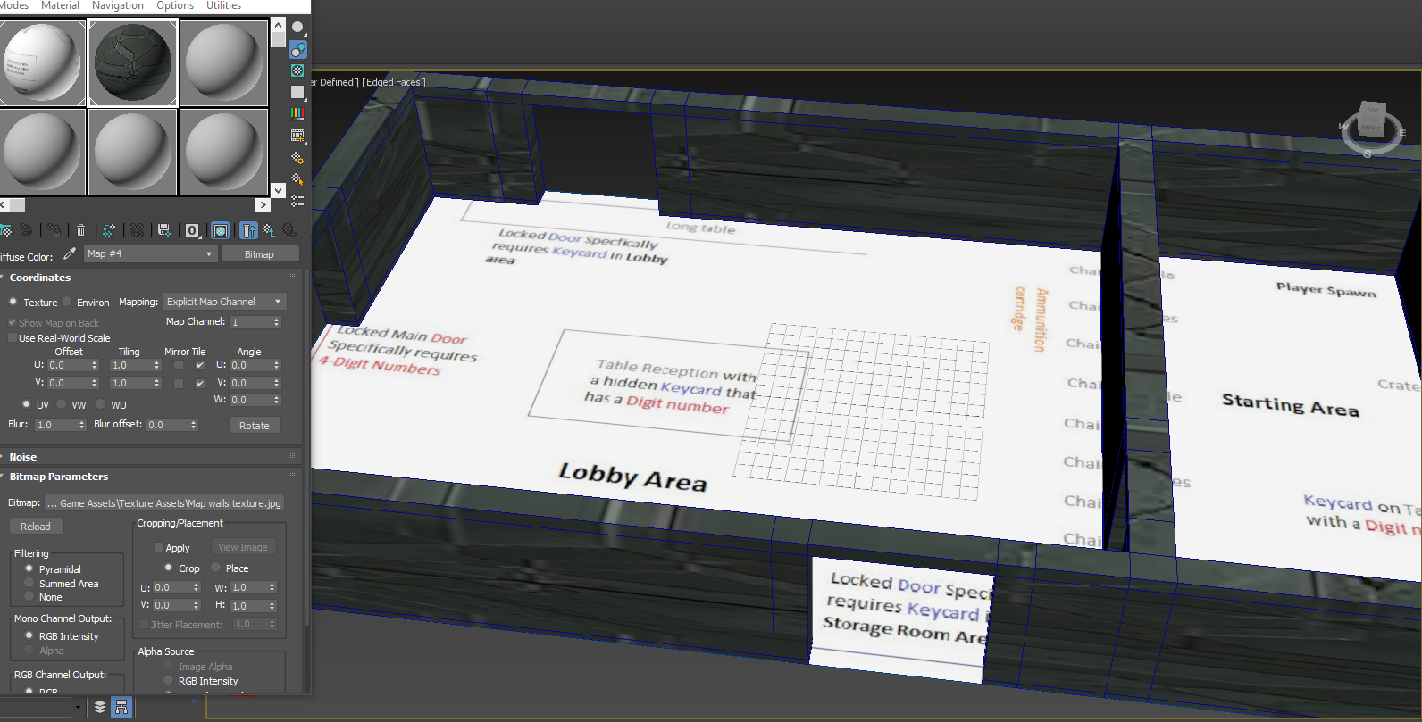

Apply UVW Map to the walls

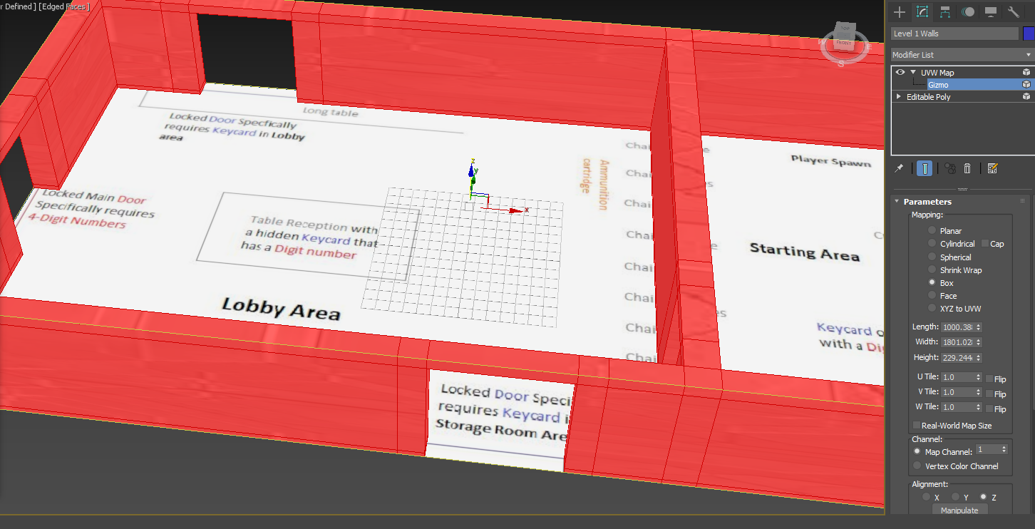

Rotate and Rescale map walls with the UVW Map using Gizmo

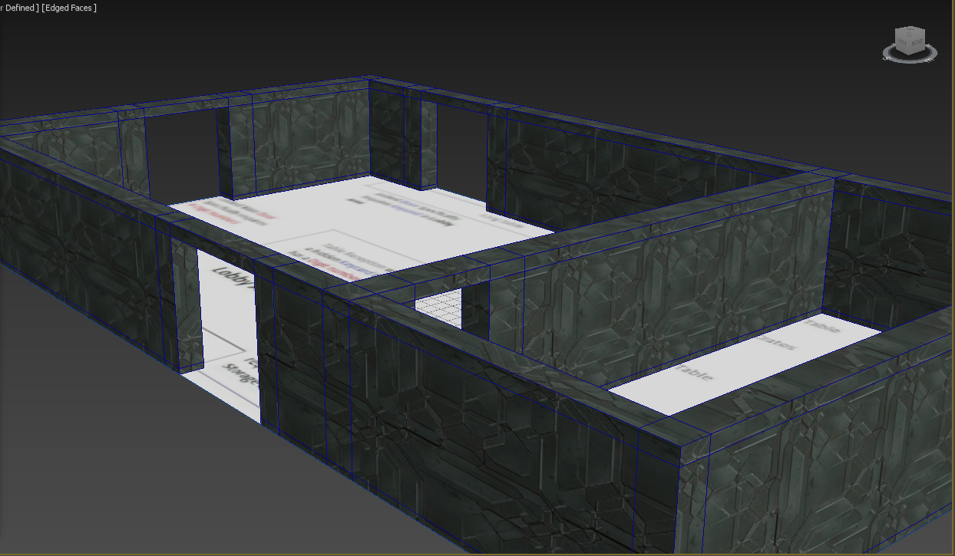

Replaced the map level 1 plan with floor texture

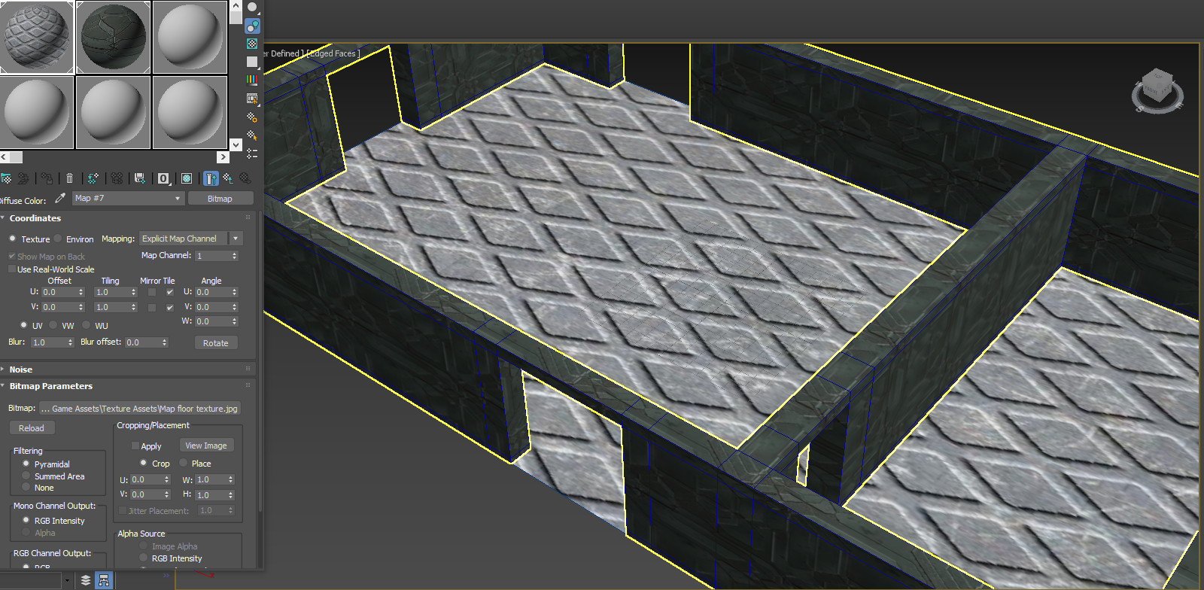

Rotate and Rescale map floor with the UVW Map using Gizmo

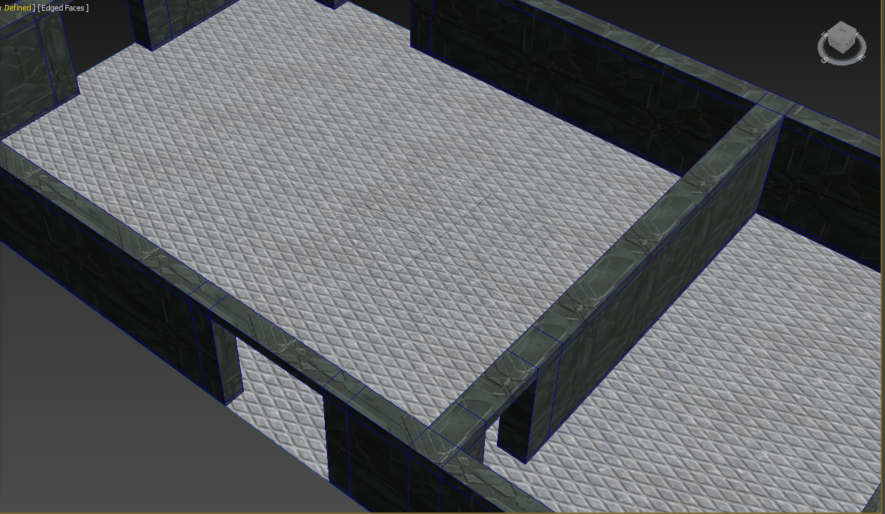

Updated version of level 1

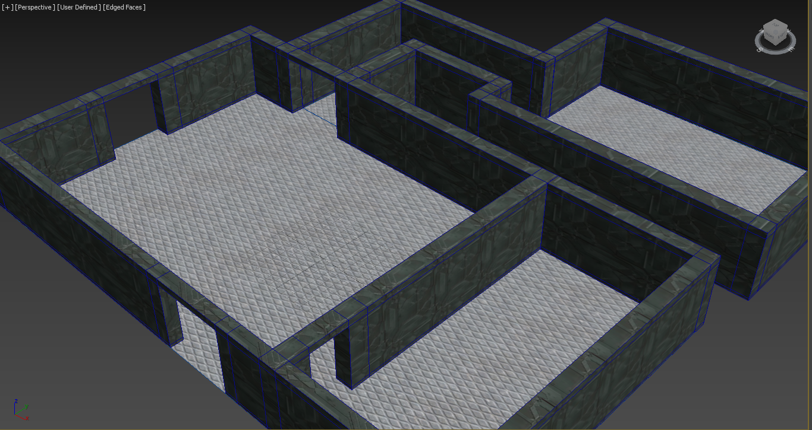

**Level 2** layout foundation

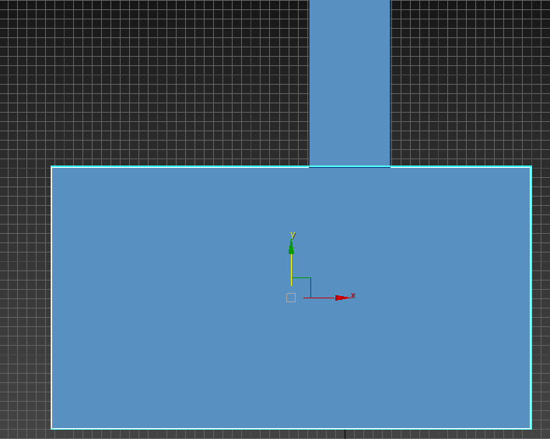

Extrude tool

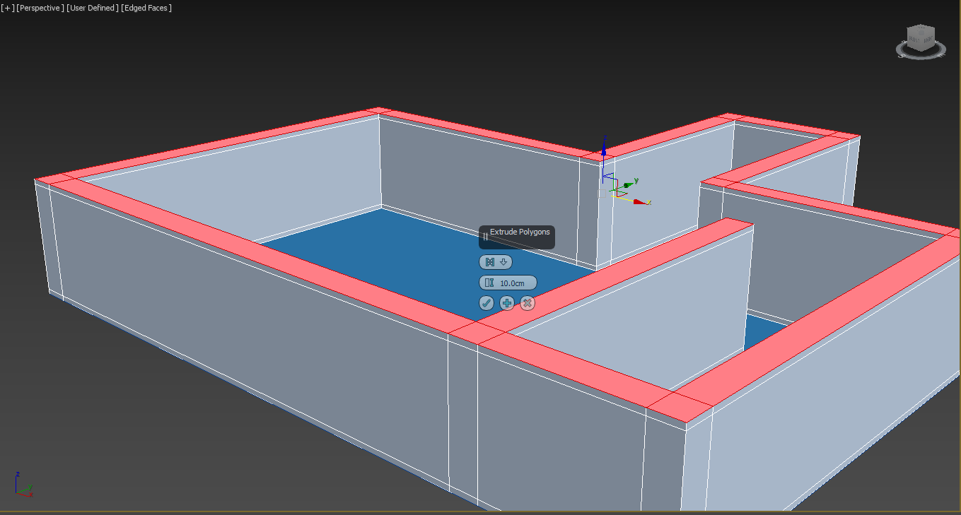

Export and apply textures for walls and floor

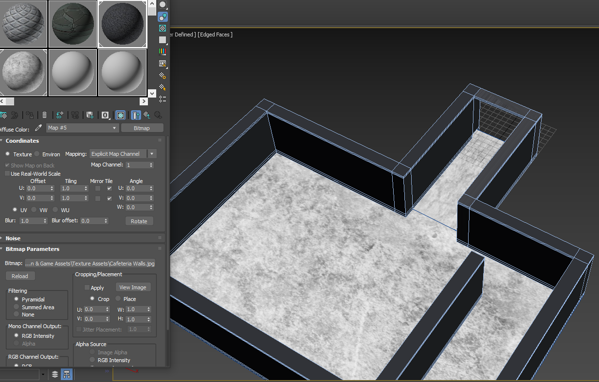

Move and rescale walls texture using Gizmo from UVW Map but floor texture was already placed correctly

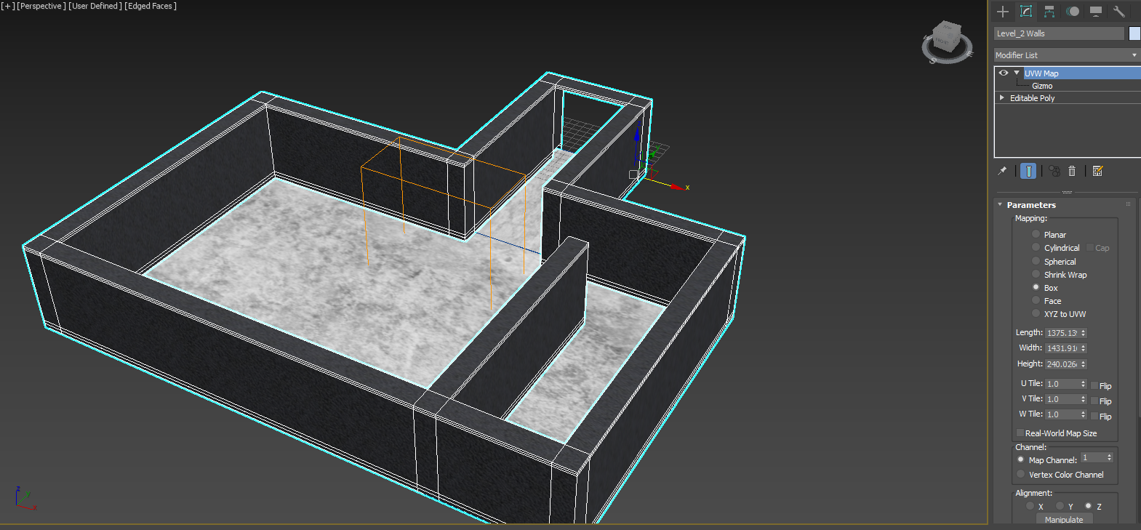

**[3D Door Modelling, Texturing and Simple Animation]**

**Door** foundation using Box from Standard Primitives

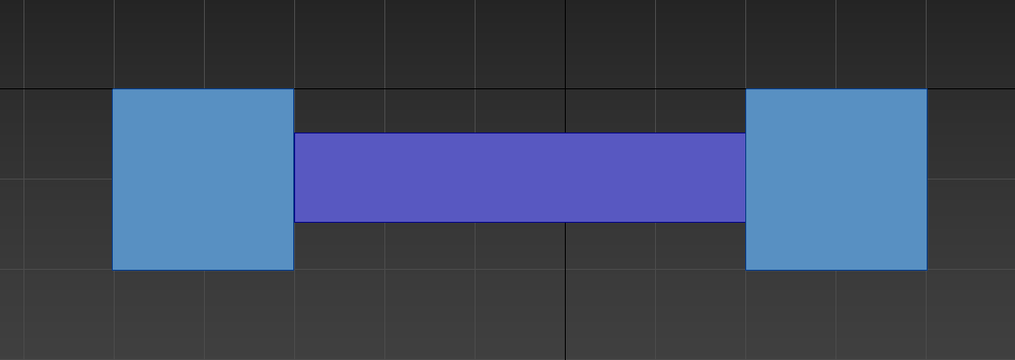

Export and apply **Door** Textures

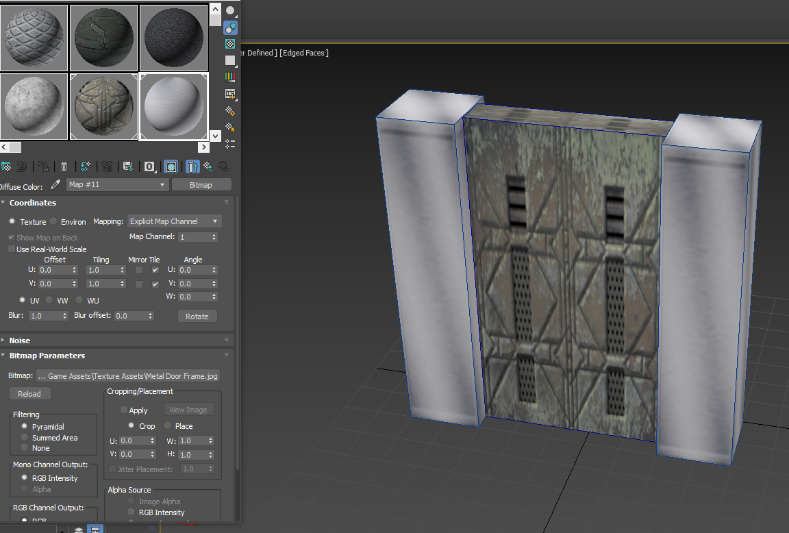

Move and rescale using Gizmo from UVW Map

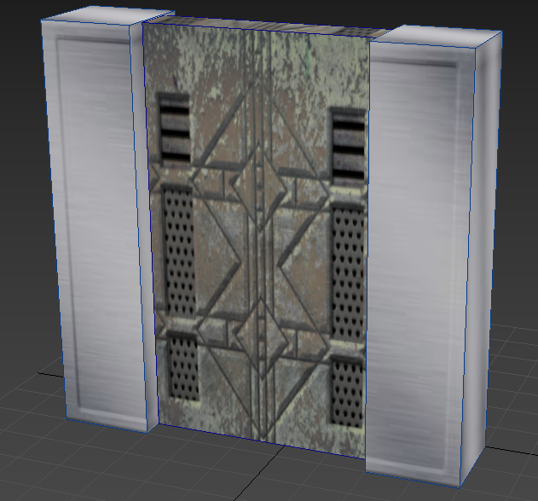

Make a simple animation using keyframes by pressing ‘n’

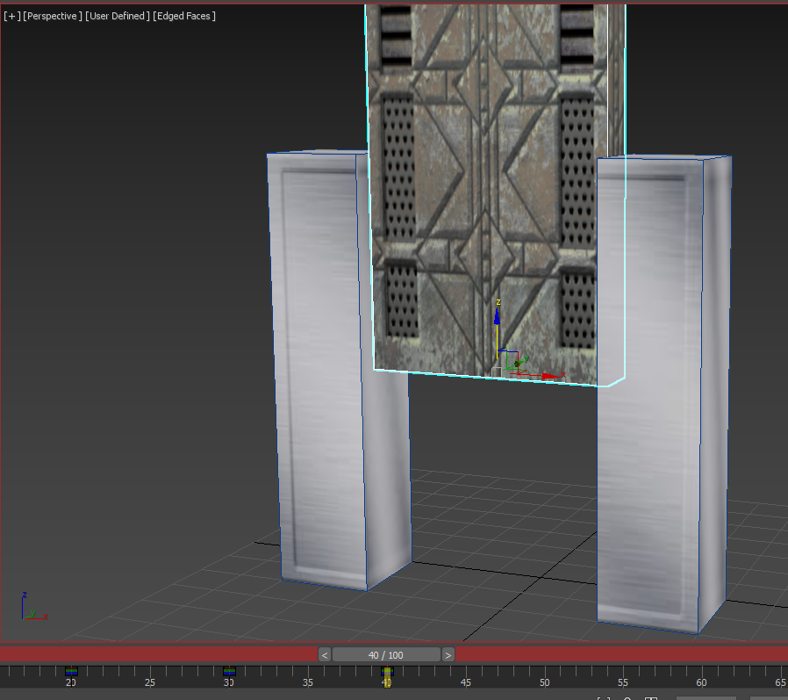

**[3D Scenery Objects Modelling and Texturing]**

Bitmap using Material Editor

**3 keycards in level 1**

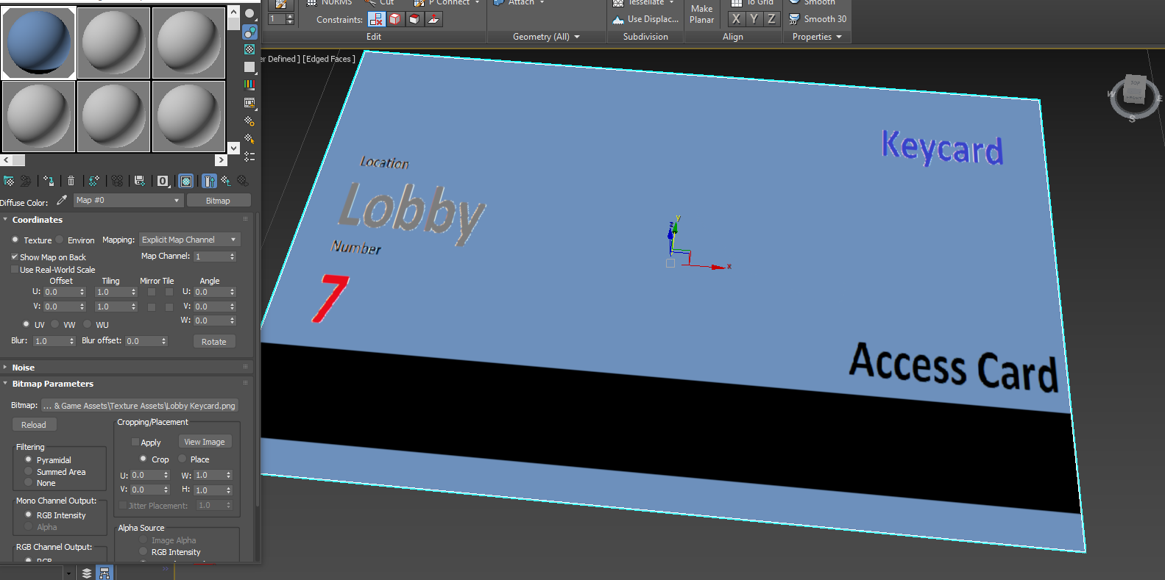

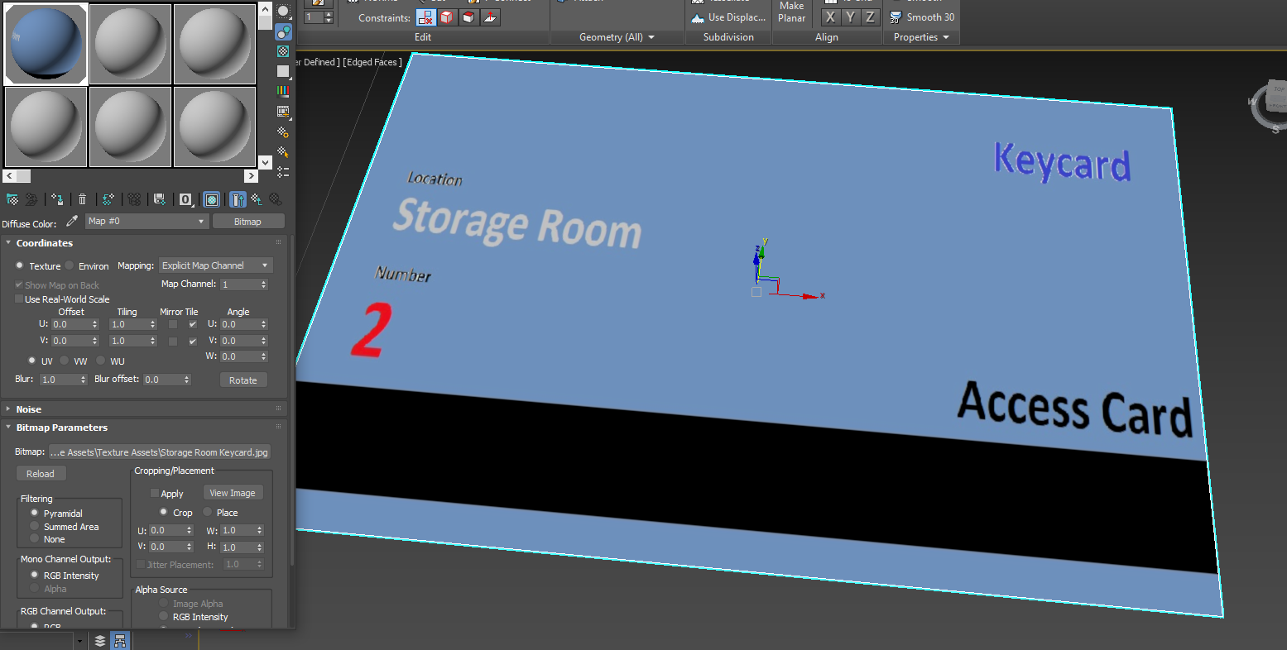

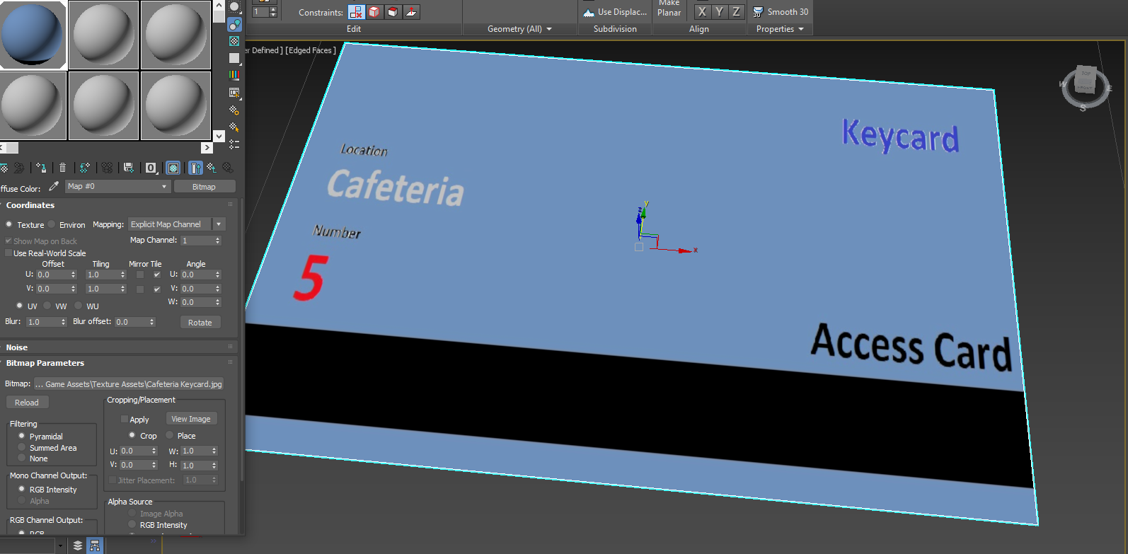

**Missing number note** with NURBS

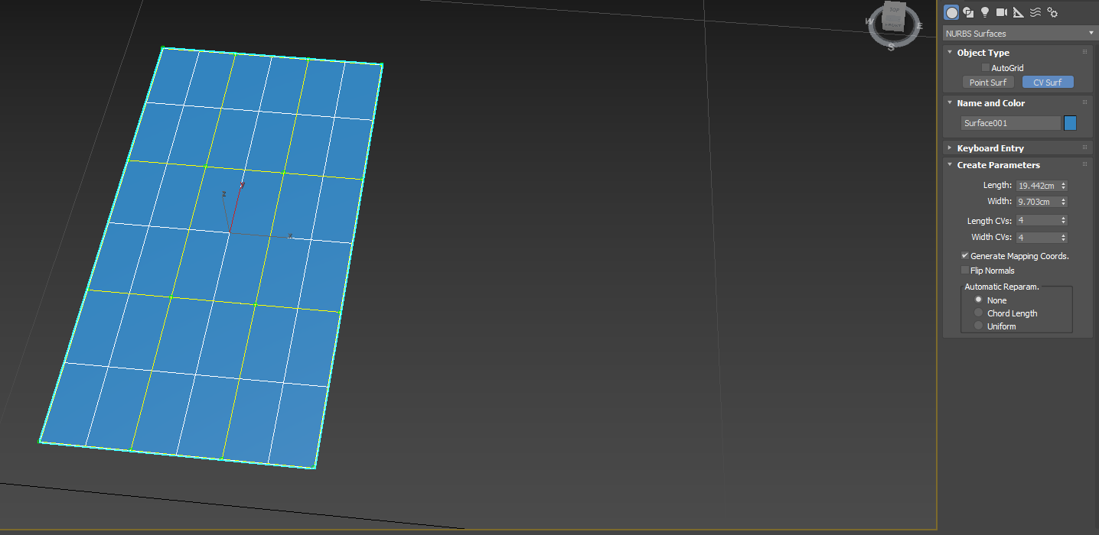

NURBS Surface CV tool

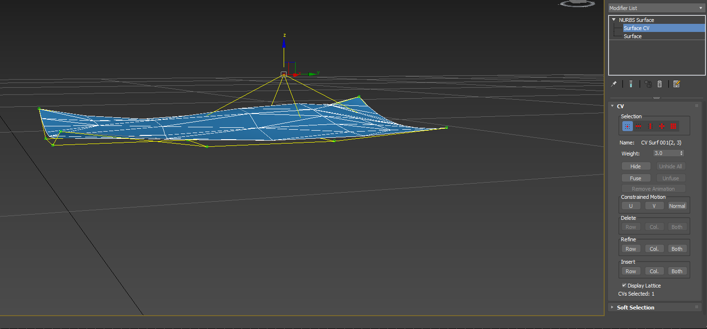

Add note texture (JPEG) by using material editor

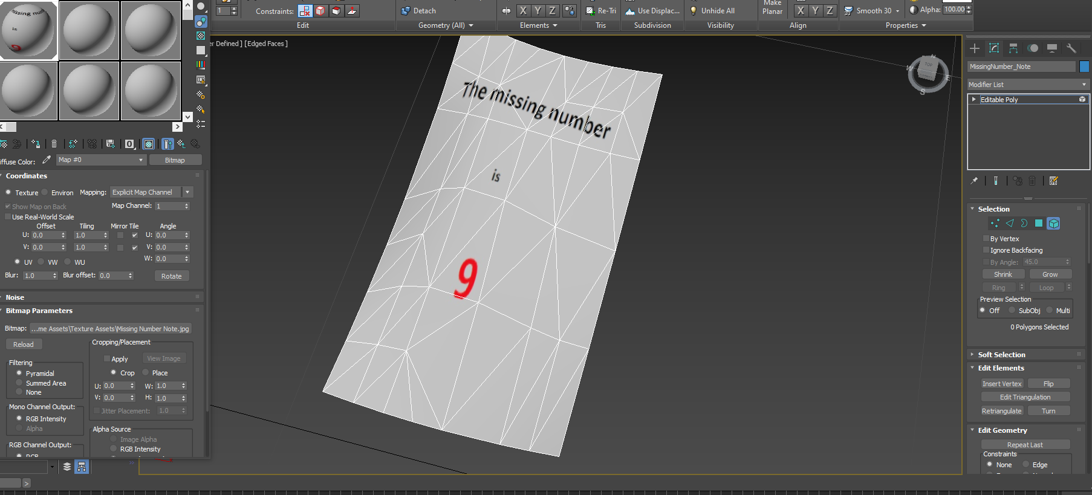

Texturing a **Crate** using UVW Unwrap

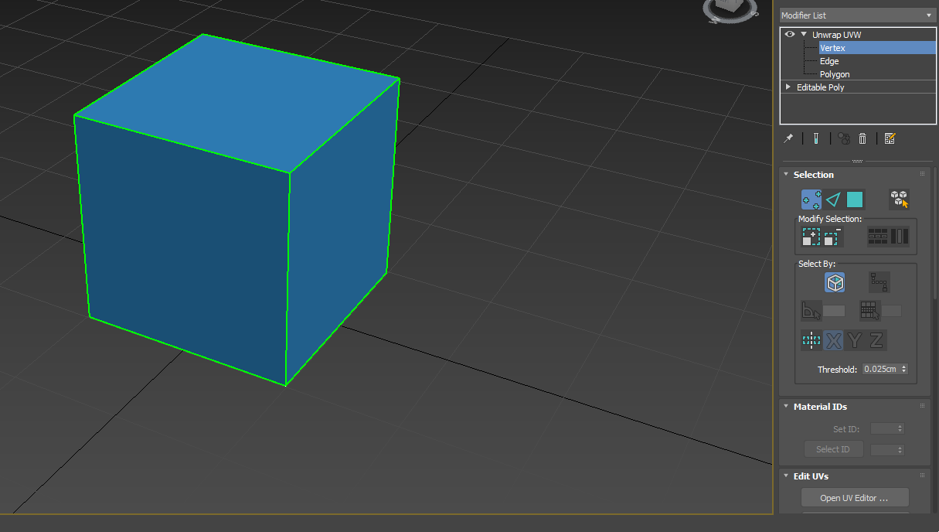

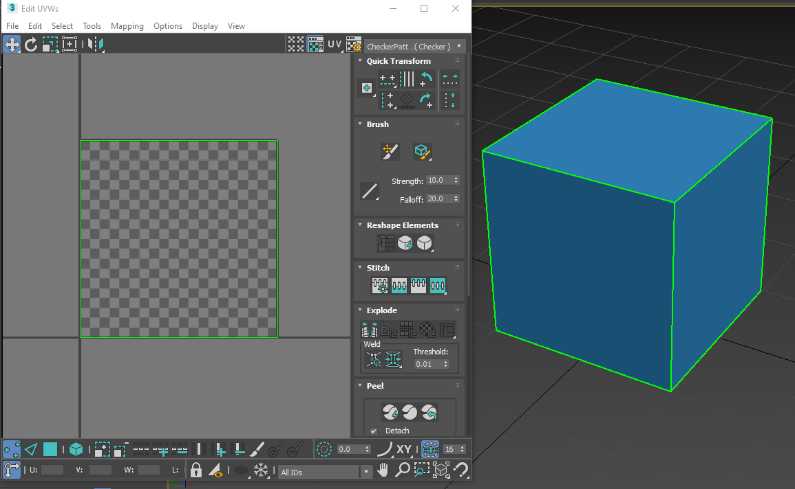

Unfold Mapping from Mapping in the tab and then save the UVW Unwrap into BMP File

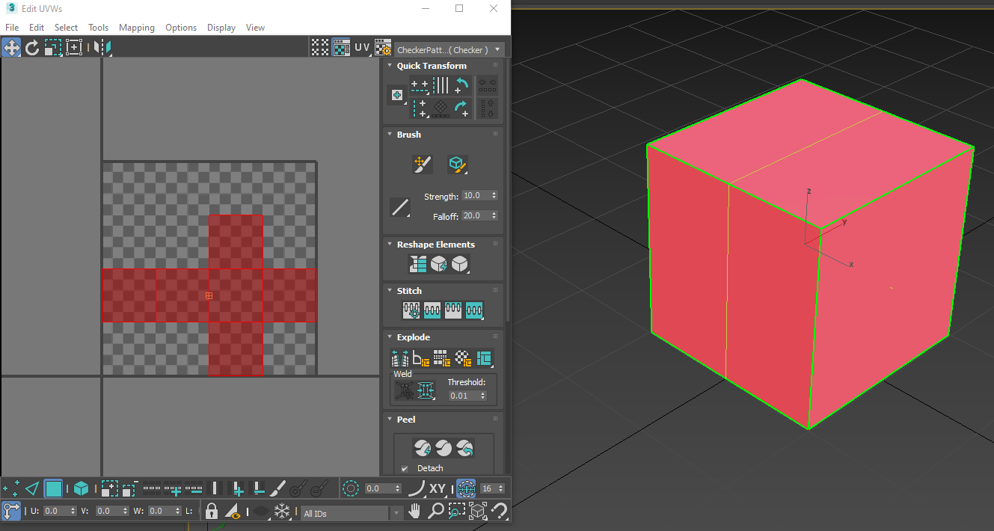

Place the crate texture in correct places using Paint

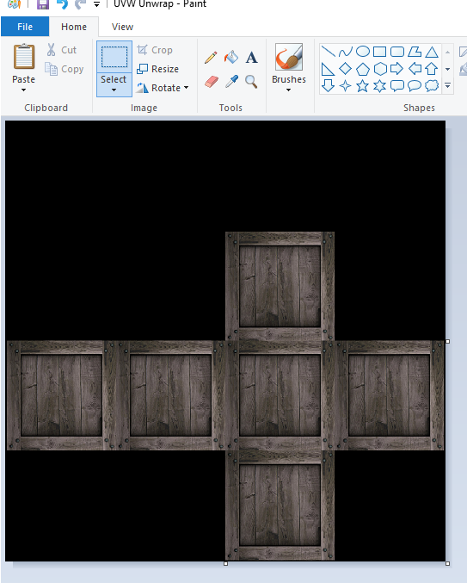

Then apply the UVW Unwrap into Material Editor

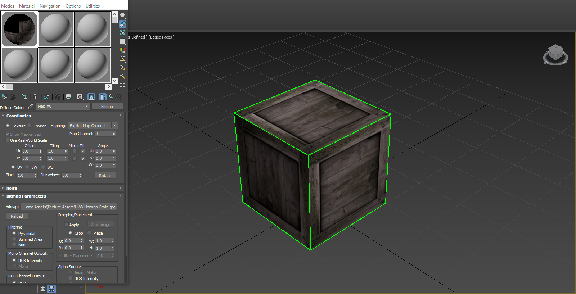

Texturing an **Ammo Box** using UVW Unwrap and peeling the box using Unfold Mapping

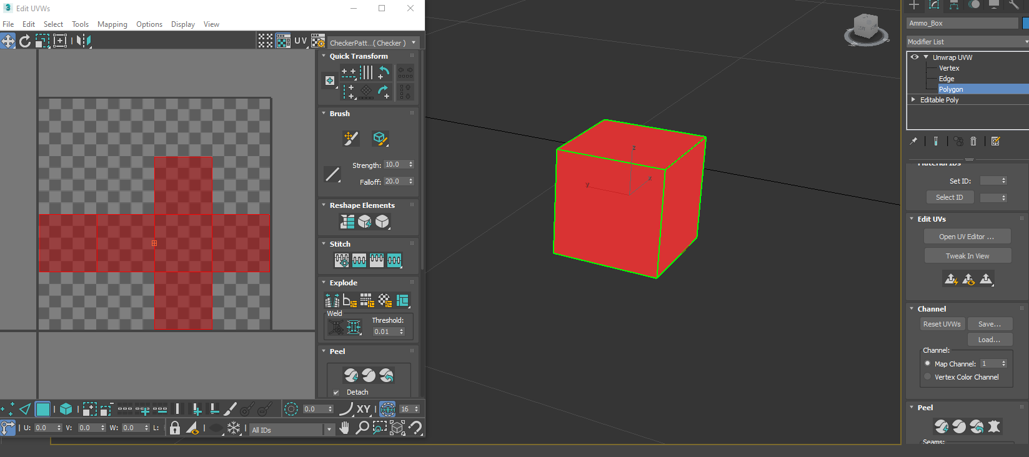

Place the ammo box texture in correct places using paint

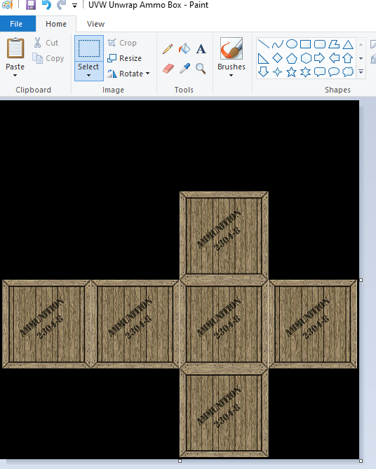

Then apply the UVW Unwrap into Material Editor

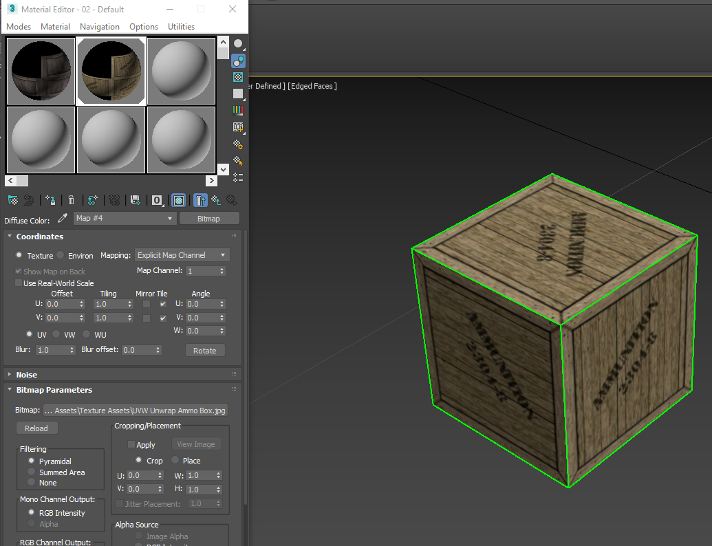

Plane object to create a gun

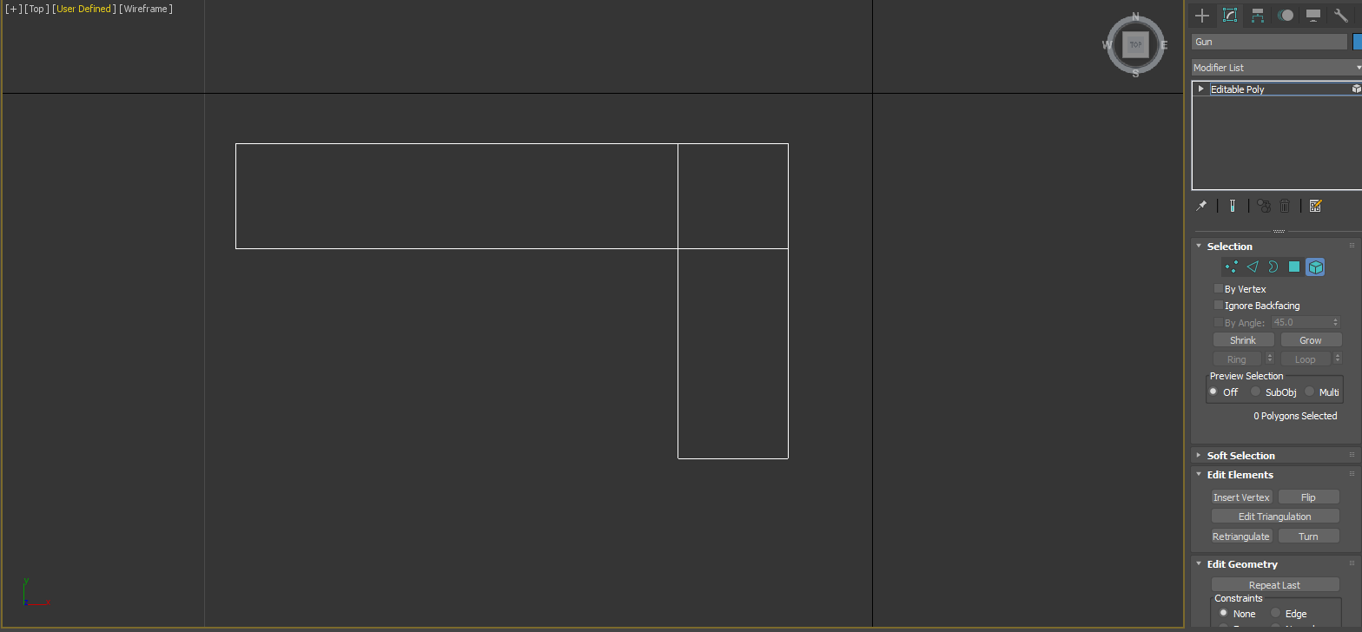

Extrude Tool

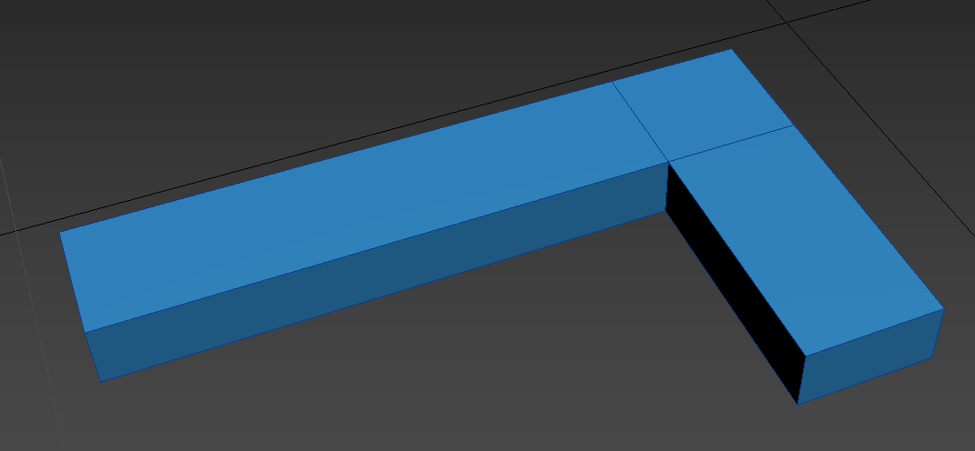

Sphere using Boolean Compound with Subtract

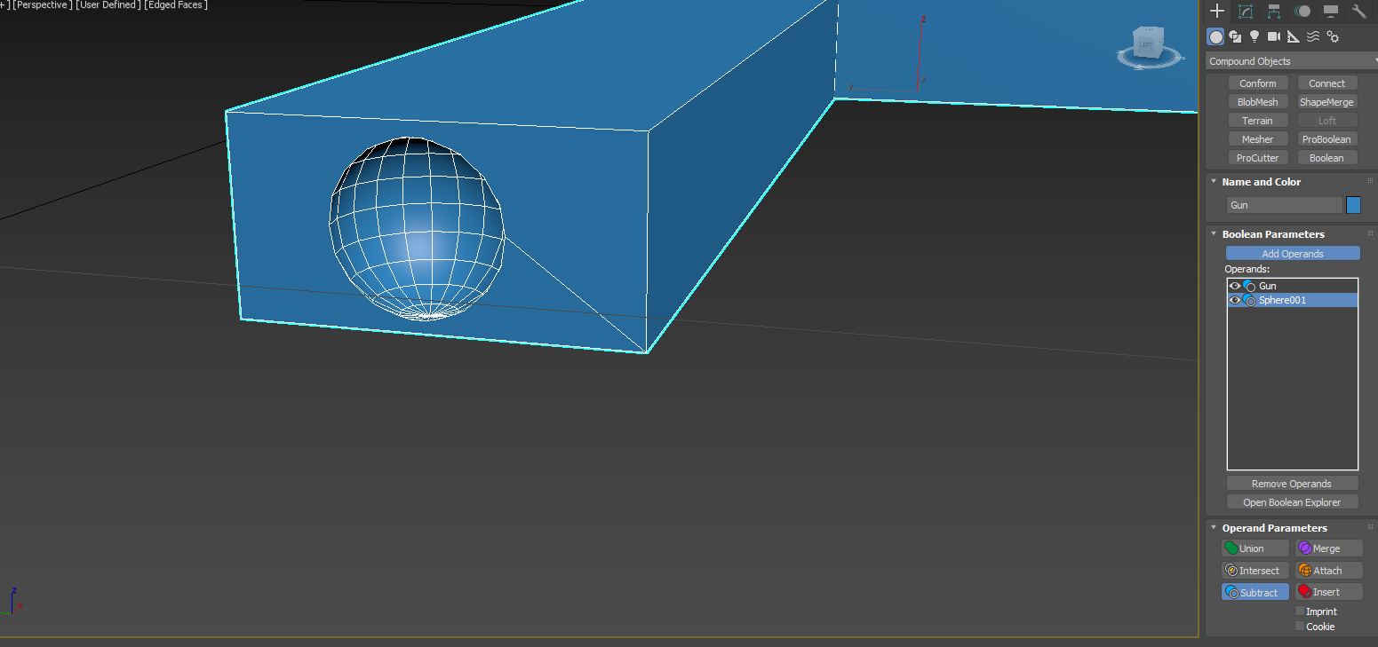

Apply Matte Aluminum using Material Editor

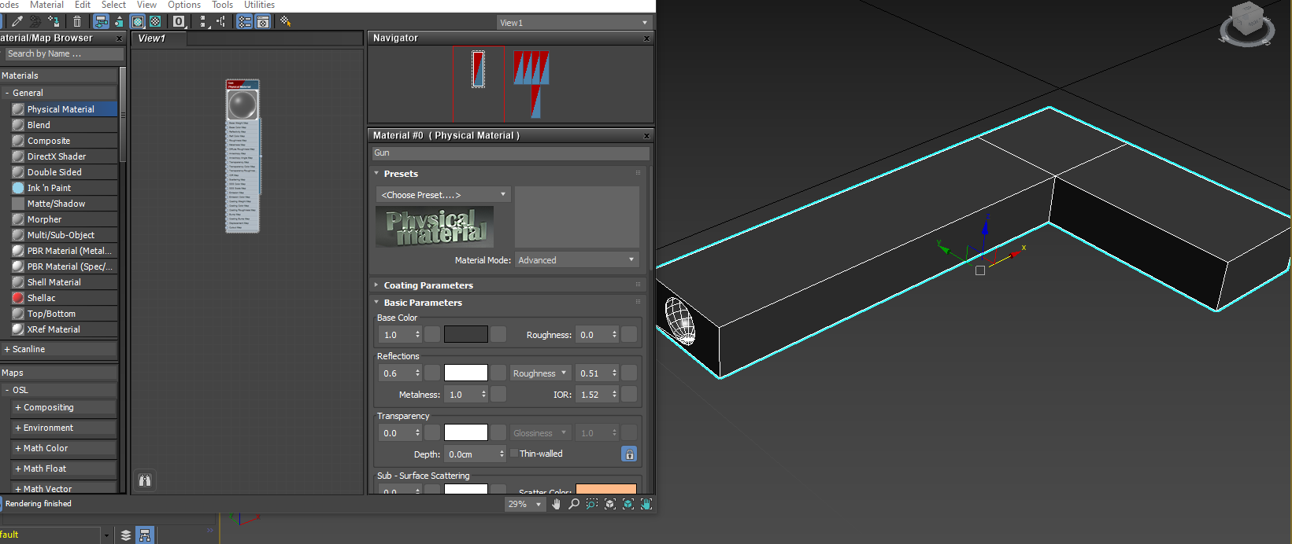

Making **Table** stand with Chamfer tool

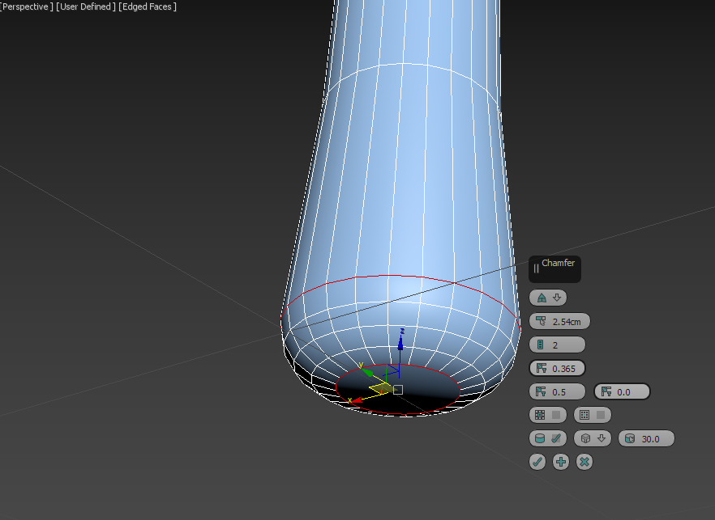

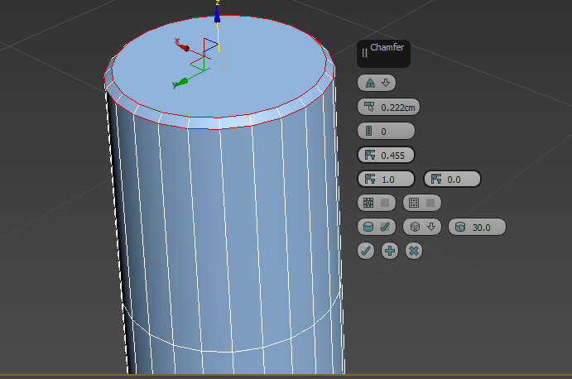

Make another 3 copies

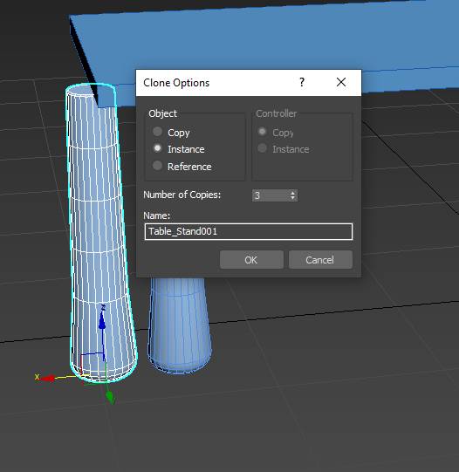

Place the 4 table stand correctly in terms of equal/opposite coordinations

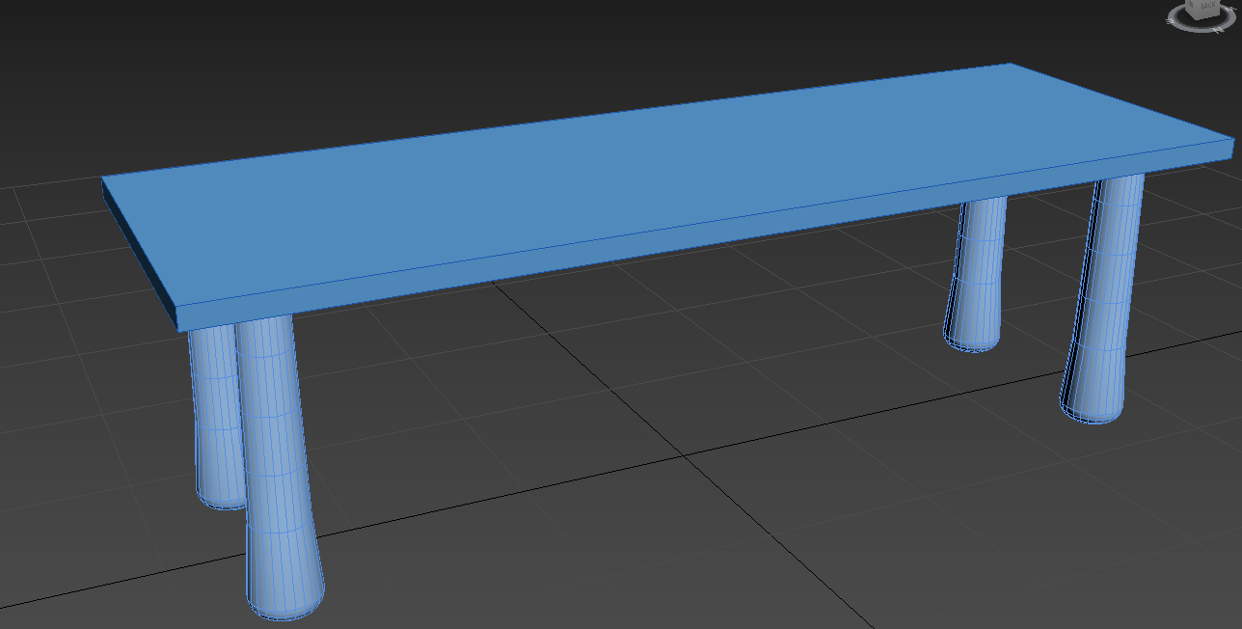

Chamfer tool on 4 corners of the table

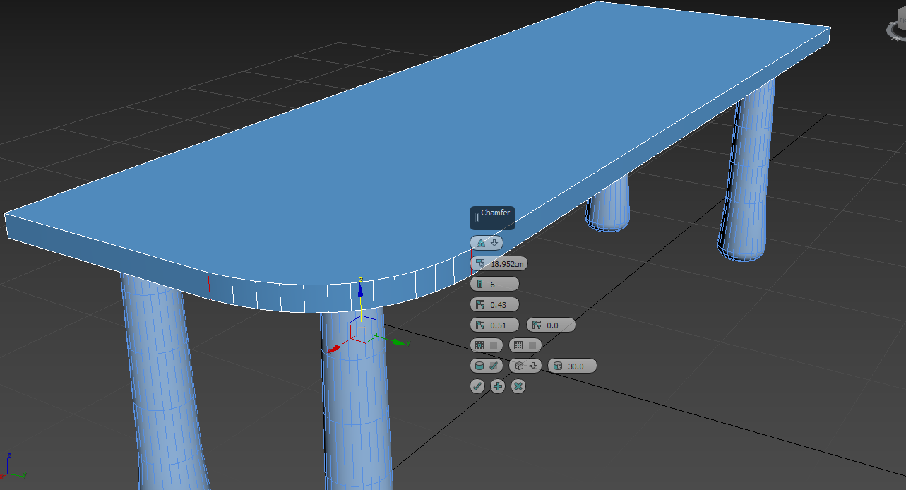

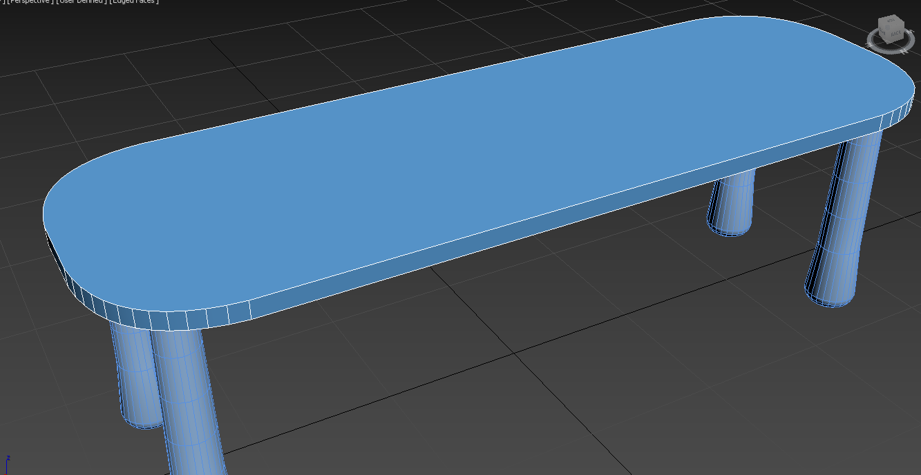

Extrude tool on top of the table stands

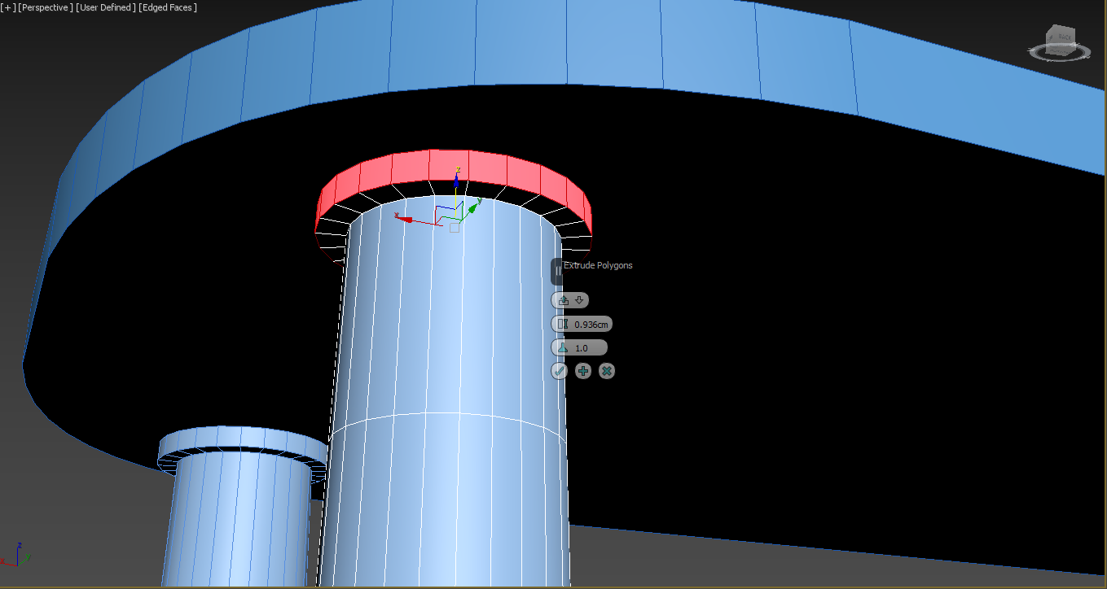

Relax tool to make it smooth

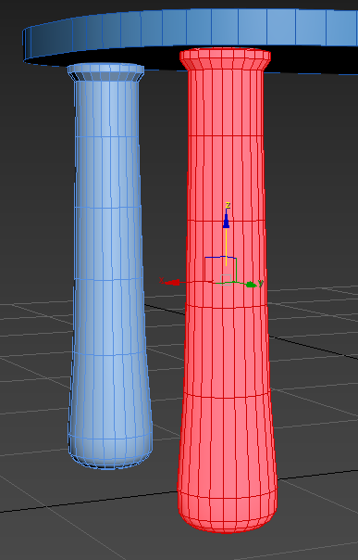

Apply Glossy Plastic and Aluminum material in Material editor

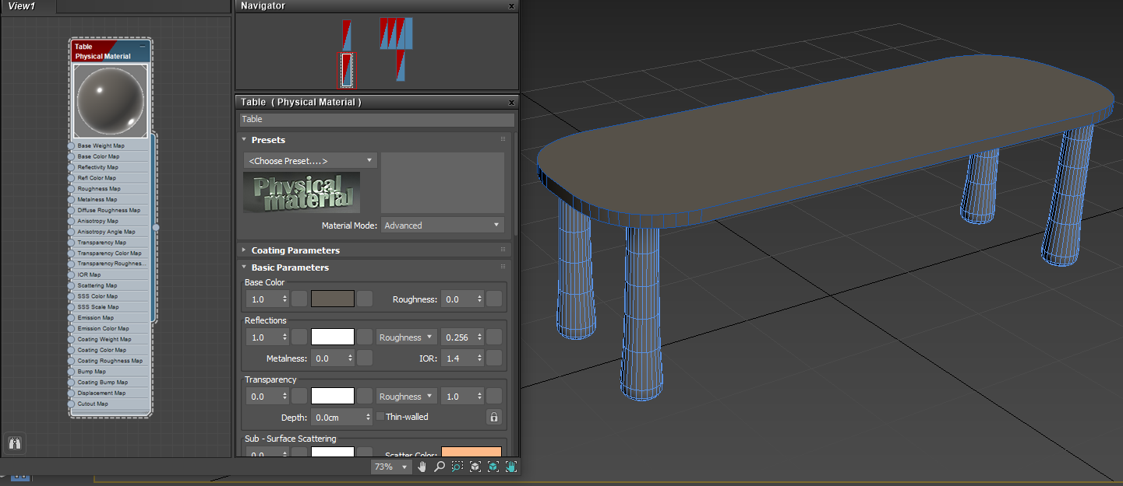

Splines tool to make a **Chair** seat foundation using NGon

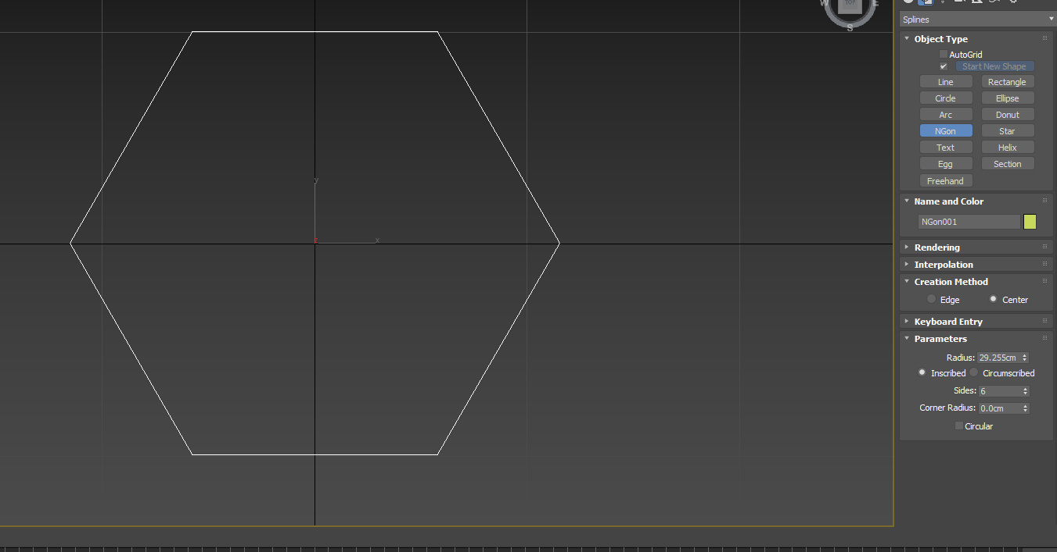

Circular shape and convert it to Editable Splines

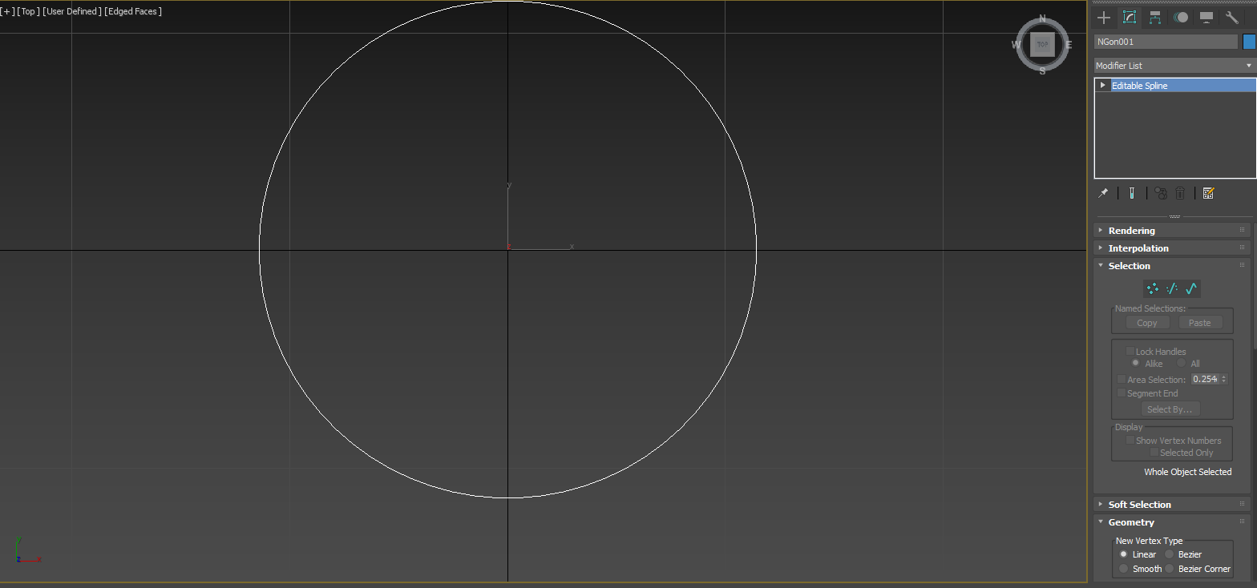

Move and rescale as well as apply Cross Section Modifier

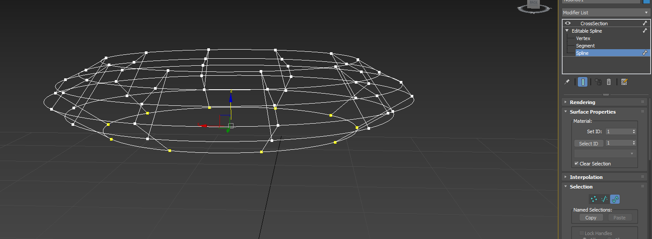

Apply Surface Modifier

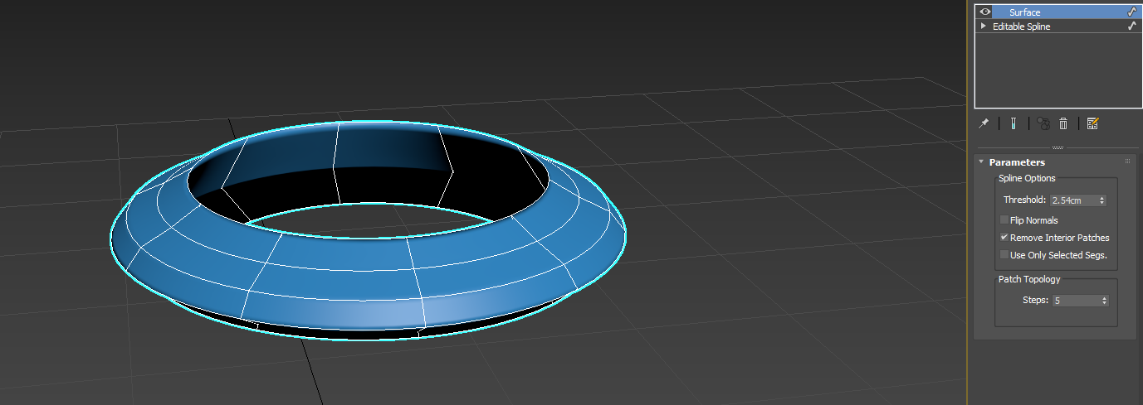

Convert it to Editable Poly and apply Cap Holes before collapsing

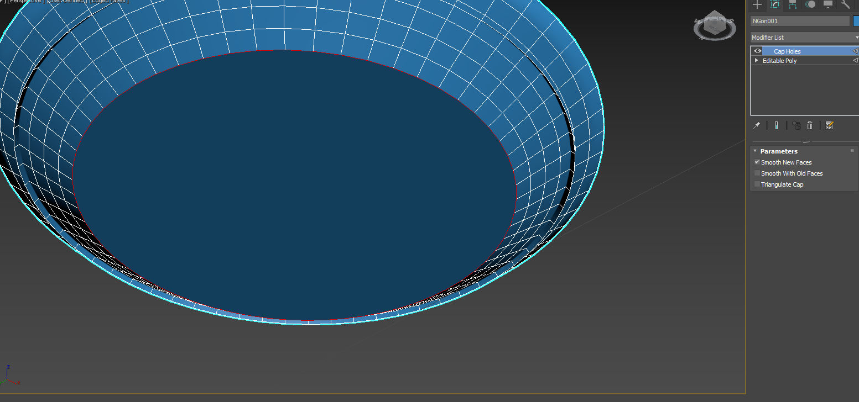

Inset tool

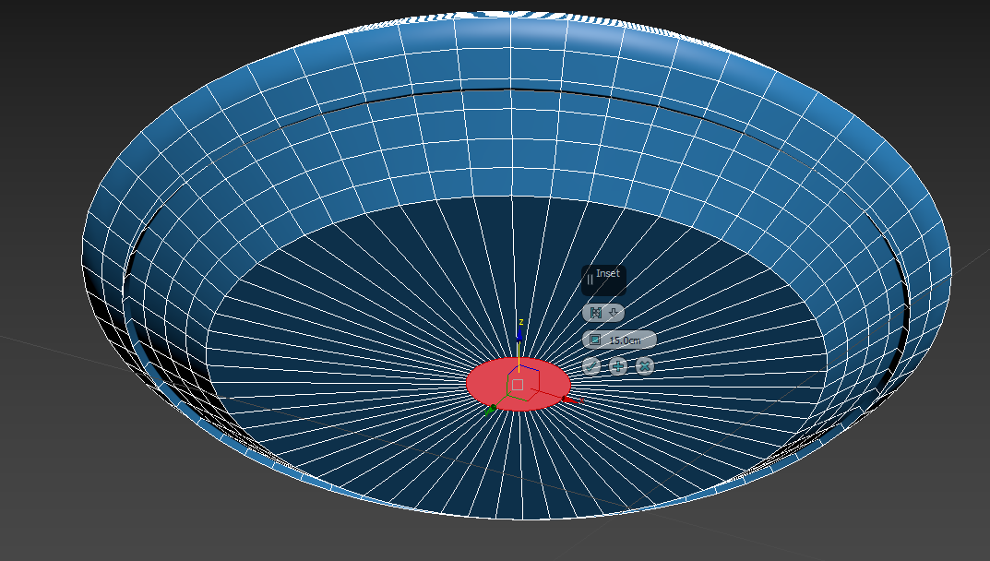

Extrude Tool

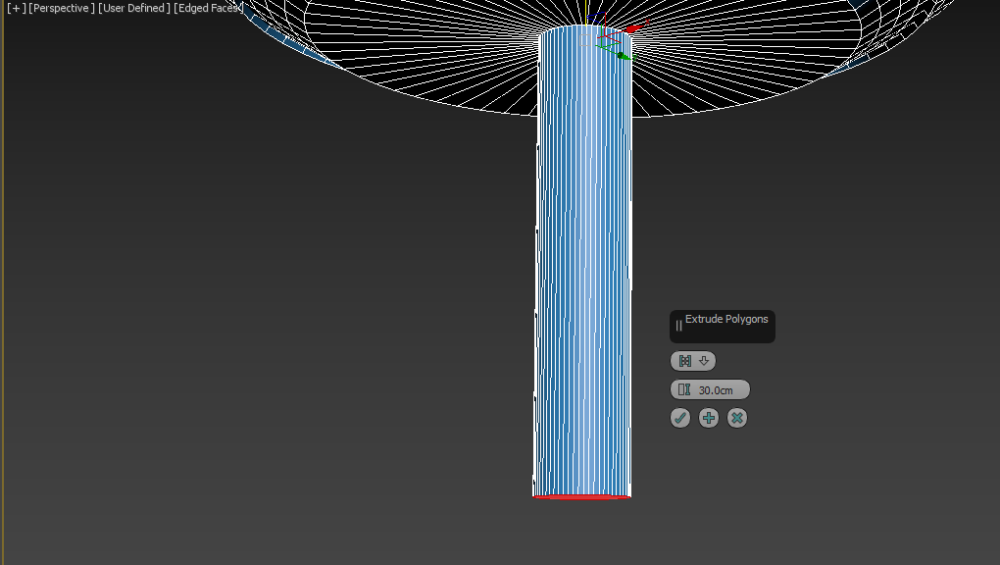

Bevel Tool

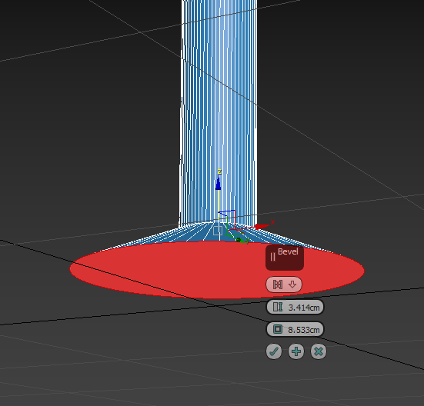

Extrude Tool

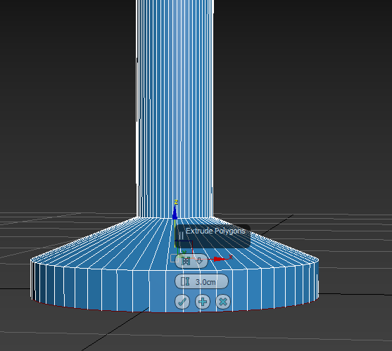

apply Glossy Plastic and Aluminum using Material Editor

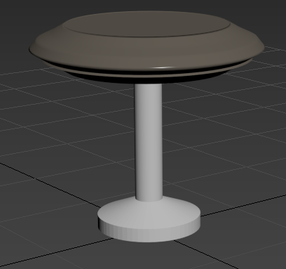

**[Audio using Audacity]**

Imported a walking audio in Audacity

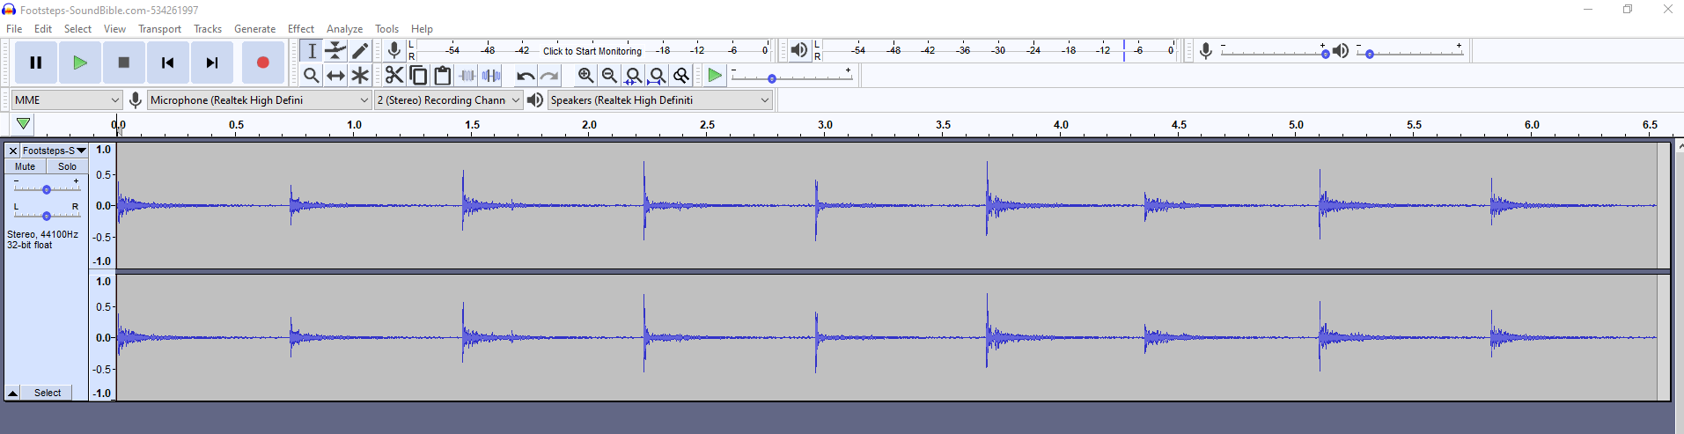

Change Tempo

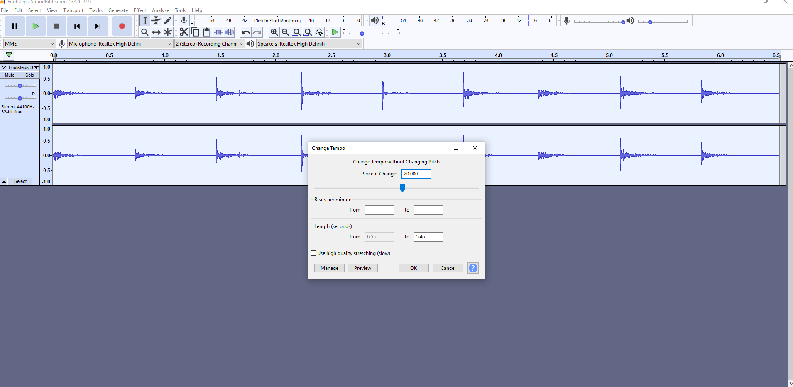

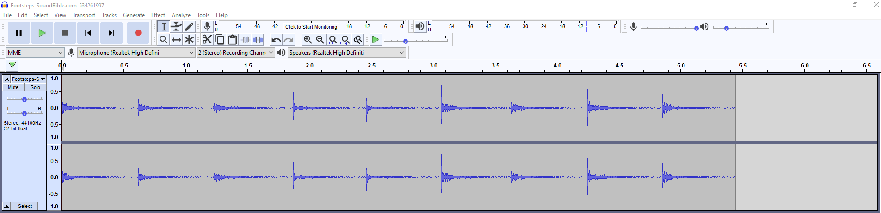

Imported a background ambience

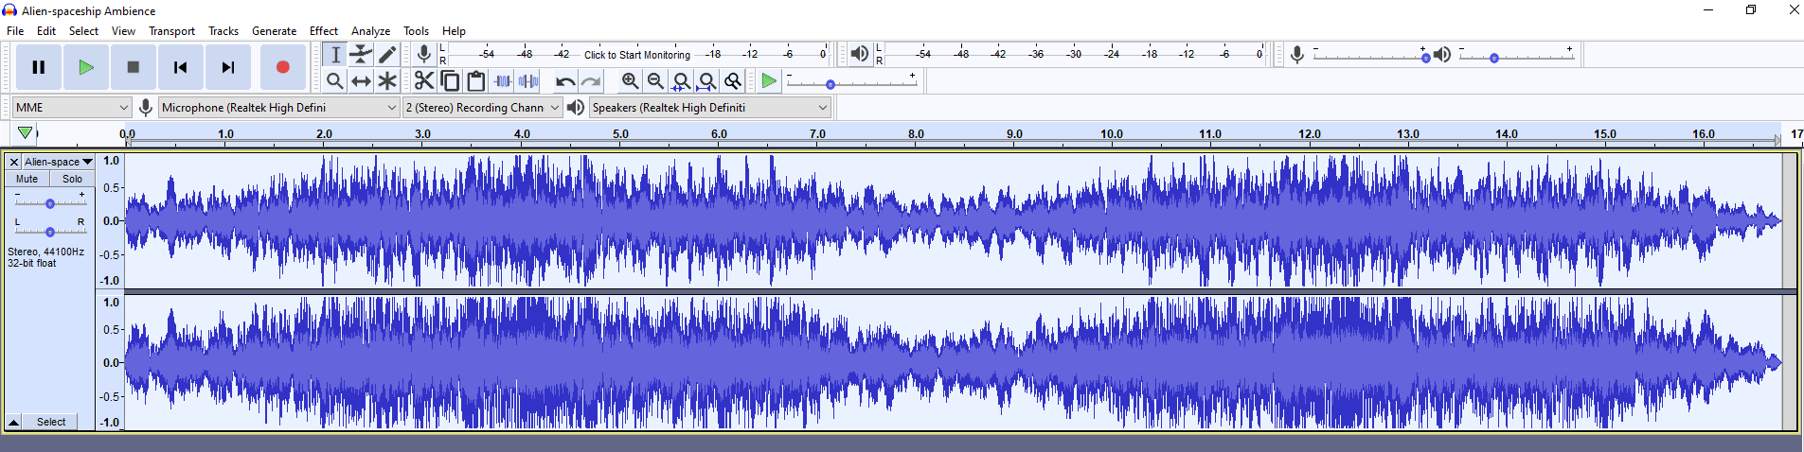

Amplified to lower the volume of the whole track

